Ancient Arrow

Chamber 1: Listening
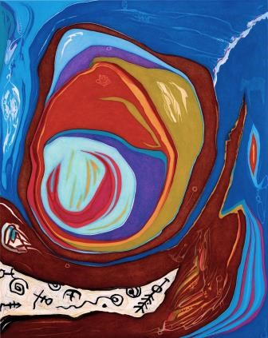

I am listening for a sound beyond sound that stalks the nightland of my dreams, entering rooms of fossil-light so ancient they are swarmed by truth.

I am listening for a sound beyond us that travels the spine’s invisible ladder to the orphic library. Where rebel books revel in the unremitting light. Printed in gray, tiny words with quicksand depth embroidered with such care they render spirit a ghost, and God, a telescope turned backwards upon itself dreaming us awake.

Never-blooming thoughts surround me like a regatta of crewless ships. I listen leopard-like, canting off the quarantine of bodies sickened by the monsoon of still hearts. There is certain magic in the heartbeat which crowds the sound I seek, but it is still underneath the beating I wish to go. Underneath the sound of all things huddled against the tracking dishes that turn their heads to the sound of stars.

I am listening for a sound unwound, so vacant it stares straight with the purity to peer into the black madness of time sowing visions that oscillate in our wombs bearing radiant forms as the substrate of our form.

When I look to the compass needle I see a blade of humility bent to a force waylaid like wild rain channeled in sewer pipes. Running underground
in concrete canals that quiver,

laughing up at us as though we were lost in the sky-world with no channel for our ride.

I am listening for a sound in your voice, past the scrub terrain of your door where my ear is listening on the other side. Beneath your heart where words go awkward and light consumes the delicate construction of mingled lives. I can only listen for the sound I know is there, glittering in that unpronounceable, stateless state quarried of limbs so innocent they mend the flesh of hearts.

Ancient Arrow

Chamber 2: Temptress Vision

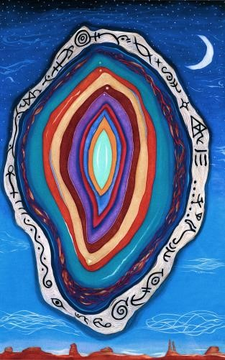

A temptress vision has encircled me like a willful shadow of a slumbering dream.
Is it the powerful light of purpose?
If I squint with all my strength I may see it. Always must it be inside of me like a pilot fi sh inseparable from its host.
It fearlessly drinks my essence.
Such a bitter taste I muse.
Spit it out upon your table of perfection.
Compare this grain of sand with your galaxy.
This spire of sorrow with your deepest eye. If my callous mind can see you, there are no interventions.
No pathway away.
Convergence.

I am a lock-picker.
A tunnel-digger.
A fence-cutter of the wicked watchers. A traveler that has sought the mystery that eludes all but the outlaws. The wild-eyed, unrelenting fools of purpose that remain outside the laboratory of wingless flight.

You are the eternal Watcher who lives behind the veil of form and comprehension, drawing forth the wisdom of time
from the well of planets.
You cast your spell and entrain all that I am.
Am I just a fragment of your world?
A memory hidden by time? A finger of your hand driven by a mind unfamiliar with skin.
Touch yourself and you sense me.
Visions wild with love.
Splendor that beckons like a secret whisper of gladness spread on the winds by an infinite voice.
The sound of all things unified.
I am part of that voice.
Part of that sound.
Part of that secret whisper of gladness.

This limitation must end in lucid flesh. The dream of sparks ascending quickening the cast of hope. Avoid the brand of passivity the signs complain.
Shun manipulation before you are stained. Spurn all formula and write new equations in the language of sand. Heed no other, nor listen to the seduction of holy symbols standing before the windows of truth.
Define from a foreign tongue.

These are the battered keys that have led me to unlocked doors. Doors that collapse at a mere breath
and behind which lay more pieces to collect for the Holy Menagerie.
The never-ending puzzle.

All the stars in the sky recall the purpose of your hallowed light.
Burn a hole through the layers.
Peel all the mockery away. Enjoin the powers to answer this call: Bring the luminous vision hidden behind the whirling particles of the Mapmaker.
Let it enter me like a shaft of light that enters a cave’s deepest measure.
Ancient fires still burn in these depths.
Who tends them?
What eyes are watching? Waiting.
Waiting for time’s flower to bloom. To submerge in the relentless subtlety that moves beyond my reach with a jaguar’s stealth.
To dream of elder ways that leap over time and leave behind the puzzle of our making.

O’ temptress vision you steal my hunger for human light. If there is anything left to hollow let it be me.
If there is anything left to cage let it run free.
If there is anything left to dream
let it be our union.

Chamber 3: Bandages of the Beast

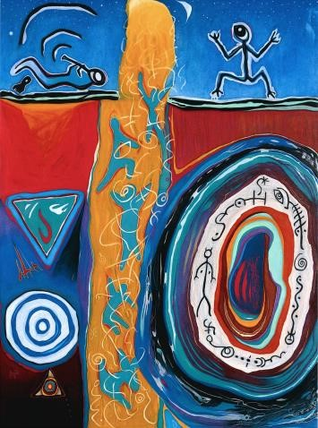

There were many random omens. Sending olive branches with thorns was only one of your repertoire. You offered me a book where all the answers lay encoded in some strange dialect.
Symbols undulating like serpents restless for food.

If I was windborne as a lambent seed you
would still the air and I would fall into the thicket. If I yearned for sweet water you would pass me the bitter cup. If I was an injured fawn you would flush me from the cloister, corner me against cold stone, and admire my fear.

Everywhere I steer I seek the one look of love; yet love humbles itself like a mannequin changing its clothes to accommodate the dressmaker.
Underneath there are bandages of the beast.
Underneath there is the tourniquet of deliverance. But beneath the shell there is emptiness, so defiant
it is clothed in finery that neither dressmaker nor beast can touch.

You have mistaken my search as my soul.
Raking through it for clumps of wisdom, you have found only what I have lost to you. Held like rootless dreams I will vanish in your touch.

If you pass your rake over this emptiness you will feel clumps of my spirit. You will find me like tiny pieces of mirror broken apart yet still collected in one spot.
Still staring ever skyward.
Still reflecting one mosaic image. Still the accompanist of myself.

Chamber 4: One Day

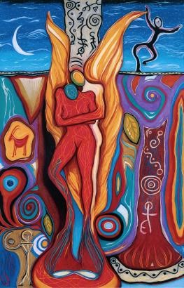

One day, out of this fleshy cocoon I will rise like a golden bird of silent wing graceful as the smoke of a fallen flame. I will dream no more of places
Hidden—secreted away in heaven’s cleft where the foot leaves no print.

One day,
I will walk in gardens holding hands with my creation and creator. We will touch one another like lovers torn by death to say goodbye.
We will lay in one another’s arms until we awaken as one invisible to the other.

One day,
I will isolate the part of me that is always present. I will dance with it like moonlight on water. I will hold it to myself in a longful embrace that beats perfection in the hymn of the Songkeeper.

One day, when I curl away inside myself I will dream of you this flesh-covered-bone of animal. I will yearn to know your life again. I will reach out to you as you now reach out to me. Such magic!
Glory to covet the unknown! That which is is always reaching for the self that cheats appearances. Who dreams itself awake and asleep. Who knows both sides of the canvas are painted, awaiting the other to meld anew.

Chamber 5: Life Carriers

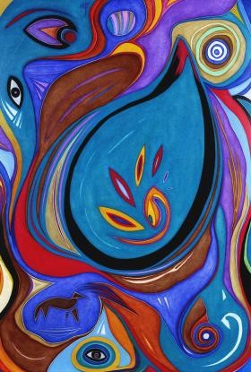

Life carriers spawn in the primal waters of a giant embryo. Their progeny will settle in human dust. Pieces of clay with tiny thoughts of flight. Knife-points veiled in turbid cloaks that shun the light of a tranquil star.

In the remote wilds the life carriers emerge and perch upon the shoulders of gray stones. They signal their desires to fly, but their homes are suited for the comforts of rain and earth.
The sky must wait.
(The dirt companion smiles.)

Circles break.
Barriers overrun. Life carriers deny their ancient pull from the ground.
Wings sprout like golden hair sinuous with nature’s artifice. Ragged feet are left behind.
The earth, replaced with vivid sky. Gravity shines its menacing stare to hold them with assertive hands.

Homeless cages are left to rot.
To sink behind the groundless sky. Earthen faces have dropped their smiles and lost their smell of fresh dirt. The dream of flight has invaded somber walls— life carriers have bounded to the other side. There they meet the next rung of the endless ladder, and trade their wings for wisdom’s eye.

Chamber 6: Of This Place

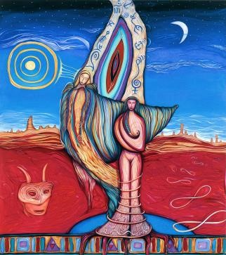

Her heart ran in the wilds of deserted plains. Sun-etched land barren of clouds and singing water. If she listened closely her hand would call and signal its thoughts upon her brow. But in this place she could only offer her arms to the sky like a tree its branches and a flower its leaves. In this dusty basin, silence gathered like smoke clearing the mind of the scoundrel.
The infidel of thoughts. Blots of yellow leaves and white bark could be seen hiding in pools of life surrounded by red rock spires. Clustered sand monuments held together by some other life form.
She wasn’t sure.
Perhaps one life is the same as another only tilted sideways. Caught from underneath by some invisible hand that animates even the coldest stone of this place.

A smile emerged and perched upon her face drinking the sun’s clear ways.
She could spear
a million miles of air in a glance and send the window of her flesh into the cloudless sky. Upon this ocean a hawk sailed ever closer. She watched the silver speck spiral overhead dreaming through its eyes. Feeling the winds gild her wings in the softest fold of time. A tree of pine sent its sky roots deep within the air to weep its sweetness. She entered, gliding through branches to every needle in their factory of air.

So strange to feel the pull of earth in flight, but she knew the antagonism well in the splendor of this place. She knew it had settled deep, lodged like permanent ink in the heart of her.
Under skin, muscle, bone it fought the single path.
What madness calls her away?
What dream is stronger than this?
What heart beats more pure?

Of this place, it is so hard to know which is host and which is guest.
Which is welcome, which is pest.
Which is found and which is lost.
Which is profit, which is cost.

She gave her prayers to the skypeople and waited for a cloud -- her signal to leave. She should return home before dusk settles in and the golden eyes peer out against the black code. In a single breath she held the ancient ways that never left. She turned them inside out and then outside in.
Again and again. Waiting for her signals in the sky.
If not a cloud...
then perhaps a shooting star. (Besides, it was too dark for clouds anymore.)

When the first star fell she held her breath afraid she would miss its spectral flight. She wondered with whom she shared its final light.
What other eyes were heaven bound in that secret moment? Was this their signal home as well? And what was it they found buried so deep in a whisper of light that none can tell?

She waited with solemn eyes for more stars to fall, to gently sweep her away from the magnets of this place. If she listened to her hand it would scratch a sign in the sand for another to take her place. It would touch the land in honor of its grace and wisdom, and become a tree, rock, hawk, or flower.

Ancient Arrow

Chamber 7: Union

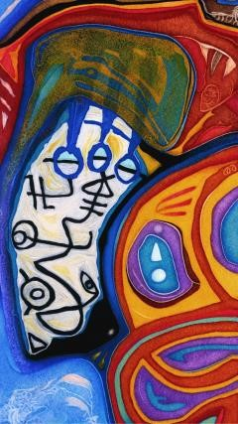

You are not here.
In this moment all that exists is here.
But you are not. There are so many footprints leading to my door. Let us enter, they say. We cannot sleep in the desert it is too cold.
Our tears will dry too fast.
Our ears will hurt from the silence.
Let us in. And so I gather them all up, swing wide my door, and step aside as they enter hoping they will lay in peace beside my fire.

You were not among them. I looked everywhere for your face and saw only mimicry. The blind eye buried behind brain searching for your heart. An antenna so alert there is a peculiar nearness of you flying inside my body.
I can hold this like a tiny bird in my hands; fragile, vulnerable, waiting for my move to decide its fate.

You are not here. I wish I could reach your skin, remove the camouflage tearing it away like black paper held before the sun as a shield. Unbundle you from your other lives and distill you in my now. You are my last love, my final embrace of this world and all the others that drop their prints at my door are dimmed by your approaching steps.

I can see you will be here soon. There is victory in my heart and something invisible yet massive wants to speak.
Reminding me of you and your coming. Quick, I plead, give me your lips. Give me your womanly tenderness that understands everything so I may lose myself in you and forget my loss.

If you were here, I would tell you this secret. But you would need to be staring up at the stars when I told you, held within my arms feeling the earth rise up beneath you like a holy bed.
You would need our union to be your ears.

Ancient Arrow

Chamber 8: Another Mind Open

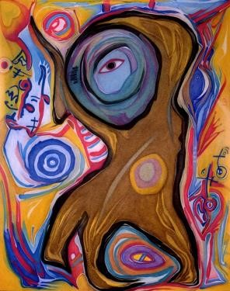

There was a fire where smoke gathered and danced like rivers without gravity to the rattle of drums.

Sometimes I would look inside the smoke but it curled away and covered itself with a cloak so opaque I could only cry. It became the mask of its consumption.
The dream of its new life. The victorious skin always changing yet everlasting. There was a fire last night that proclaimed news of a newer testament that drinks tears, lies, vile words, even the deep fears that linger underneath the turncoat.

I usually lurch away when it calls. To me, it burns too cold like a skinwalker lost in a body devoured by time. Sometimes I would dream it alive and it would blaze—vibrant sun— more durable than a grave.

In times of stillness it would speak like a codicil of some lidless dream that words could not preserve. “The time has come to lift your gaze from the fire’s brightness and cast shadows of your own.”
The words would echo into oblivion like stars lost in the swell of the sun’s awakening.

In these flames I see my consumption fit and proper.
In its smoke
I am stored away like so many jars in a broom closet.
Waiting to flee.
Drawing my feet to oppose the floor. Struggling to reach the door inside these jars of sealed air.

Stories escape the writer’s hand and pursue me as though I alone held their vigil.
Their very soul.
When indeed these stories have never been told. They have never found words to hold though they ceaselessly try.

Fires blind nature.
They invest their life in her death. But the end is always beginning toward another end. And the dreams of the untold are always pursuing another mouth, another hand, another mind open.

Sometimes I look to the errant expression of hope, and ask it to bring its flames deeper into my heart. To burn a clear sense of purpose. To burn away the fool’s crevice and enshroud me in its skin of smoke.

Sometimes I offer myself to these flames and know they listen.
Devising my world. Reality coalesces around their finery like a tower of glass enclothes a shell of steel.

Sometimes I feel the flames send me words, notes, tones.
Enchantment.
Products of another kind. Tiny crucibles of earth that burn so brightly they can blind the sun’s creatures of whimsy.

And sometimes, without even thinking, I peek into these flames when the smoke peels away for an instant. There, behind the mask, is my future.
Our future.
The future.
The present in another world. Calling out for another mouth,
another hand, another mind open.
Ancient Arrow

Chamber 9: Of Luminous Things

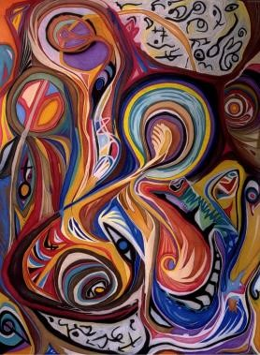

Of luminous things I have so little experience that I often think myself small. Yet when I think of you and your luminous ways my being swells with hope and prayers that you will permit the flames to grow.

In mercy, we are torn apart into separate worlds to find ourselves over and over a thousand times aching for the other half. To dream of nothing but the One between us.

Of luminous things I have squandered none nor have I held them to my heart and asked them to dissolve into me.
Yet when I think of you, I desire only this. And if you disrobed your Self and watched it watch you, you would see me as clearly as I am.
Not small and unworthy.
Unafraid of fear.
Not uncertain like empty space. But luminous like white light before the prism.

In my thoughts I hold your heart sculpting away the needless for the essence.
And when I find it I will hold it to my heart and ask it to dissolve into me. I will know of luminous things that hurtle through time bringing us the uncharted, unfathomable desire we have never spoken.
Words are not curious enough to say their names. Only love can weep their identity,
and I am so perfectly defenseless to its music.
Ancient Arrow

Chamber 10: Downstream

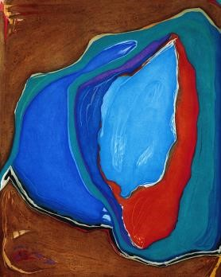

Open me.
Take me from here to there. Let the wind blow my hair and the earth’s skin touch me.

Open me like broken bottles that bear no drink yet think themselves worthy of the trash man. Open me to the clans from which I sprout. Are they colors separated, cast apart like memories of drunkenness? Open me to Africa, Asia, America, Australia. Open me like a package of mystery left on your doorstep in the sweetness of laughter.

Open me to the crudely made lens of love that screams to be of human hands and lips. Open me to the glance that comforts strangers like the tender overture of a mourning dove.

Is the wisdom of horses mine to harness? Is the muscle of wolves lawless or the healer of sheep? Is the black opal of the eye the missing link we all seek?

Open me to the authors of this beaten path and let them flavor it anew. Bring them flecks of the rumored and rotten slum that waits downstream.
Show them the waste of their watch.
The shallow virility that exterminates.
The ignominy that exceeds examination.

Open me to the idols of the idle. Let me stare open mouthed at the herdsmen who turn innocence into fear. Is the plan of the sniper to uncivilize the nerveless patch of skin that grows unyielding to pain?

Open me to the stains of this land that original sin cannot explain. Let these symptoms go like dead, yellow leaves fumbling in swift, guiltless currents downstream.

Downstream where the slum lies in waiting.
Downstream where the idols’ headstones are half-buried in muddy rain. Downstream where animal tracks are never seen. Downstream where
the lens of love is cleaned with red tissue. Downstream where the herdsmen herd their flock and beat the drums promising a new river that never comes.

Downstream there lives a part of me that is sealed like a paper envelope with thick tape.
It watches the river like the underside of a bridge waiting to fall if the seal is broken.
To plunge into the current when I am opened by some unforgiving hand unseen. To be drawn downstream in the gravity of a thousand minds who simply lost their way. A thousand minds that twisted the river
away from earth’s sweetness into the mine shaft of men’s greed.

So it must be.
So it must be.

Open me to the kindness of a child’s delicate hand when it reaches out to be held. Let it comfort me
when my bridge falls and the swift, guiltless currents
pull me downstream where all things forgiven are lost.
Where all things lost are forgiven.
Ancient Arrow

Chamber 11: Circle

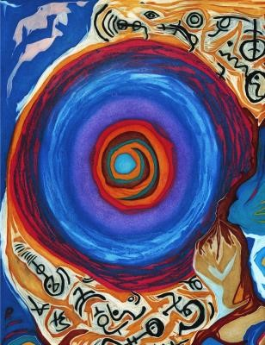

I have found the ancient mirror that leads me. I have seen its ruthless eyes that always stare, burrowing their way to the crown I wear. I have sensed the holy fire like a blazing cocoon that offers no judgments amidst its power strewn. I have felt the innocent light. Of clarity in flight over native land where we are birthed apart from one command.

I have touched the gentle eye that outlasts me.
The huge patience upon my brow. I have offered all my earthly wisdom for the symptoms of its tongue; to drop its seeds into the fields that I plow.
I have seen destiny’s path gathering its flock for the journey of endless spaces. I have watched futures fall with eyelids closed and the gnawing tears of torn places. I have seen the Tribe of Light return the clock to the black pocket where all divisions occur.
Where weeds secure the humble land
of fires unlit, yet pure.

I have heard the masters of masters speak to every cell of my body; cutting new pathways in flesh like fear’s executioner. I have watched the galaxies twirl like star wheels that spiral to the thought of a holy vision. I have felt my spirit follow the one sound that is free.

I have vanished before.
I have taken this body to an inner place where none can see.
Only feelings can hear the sound of this space. This sacred place alone has brought me here to recover the thread. To see the weaving dance that calls my name in a thousand sounds. That draws my spirit in a single, perfectly round, circle.

Ancient Arrow

Chamber 12: WingMakers

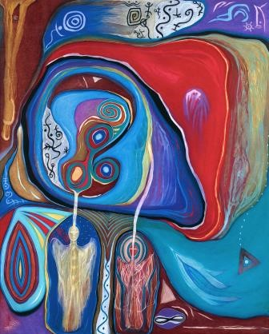

I am destined to sit on the riverbank awaiting words from the naked trees and brittle flowers that have lost their nectar. A thousand unblinking eyes stare out across the water from the other side.
Their mute voices seek rewards of another kind.
Their demure smiles leave me hollow.

Am I a perpetual stranger to myself?
(The thought brands me numb.)

Am I an orphan trailing pale shadows that lead to a contemptuous mirror? Where are these gossamer wings that my destiny foretold?
I am waiting for the river to deliver them to me; to lodge them on the embankment at my feet.

My feet are shackles from another time. My head, a window long closed to another place. Yet, there are places that salvage the exquisite tongue and assemble her wild light like singing birds the sun.
I have seen these places among the stillness
of the other side.
Calling like a lover’s kiss to know again what I have known before; to reach into the Harvest and leave my welcome.

These thoughts are folded so neatly they stare like glass eyes fondling the past. I listen for their guidance but serpentine fields are my pathway. When I look into the dark winds of the virtual heart I can hear its voice saying:
“Why are you trapped with wings?” And I feel like a grand vision inscribed in sand awaiting an endless wind.

Will these wings take me beneath the deepest camouflage? Will they unmask the secret measures and faithful dwellings of time? Will they search out the infinite spaces for the one who can define me?

Wings are forgotten by all who travel with their feet. Lines have been drawn so many times that we seldom see the crossing of our loss though we feel the loss of our crossing.
We sense the undertow of clouds. The gravity of sky.
The painless endeavor of hope’s silent prayers. But our wings shorn of flight leave us like newborn rivers that babble over rocks yearning for the depths of a silent sea.

I have found myself suddenly old. Like the blackbirds that pour from the horizon line, my life has soared over this river searching for my wings.
There is no other key for me to turn.
There is no other legend for me to face. Talking to flowers and gnarled trees will only move me a step away -- when I really want to press my face against the windowpane and watch the WingMakers craft my wings.

Chamber 13: Nameless Boy

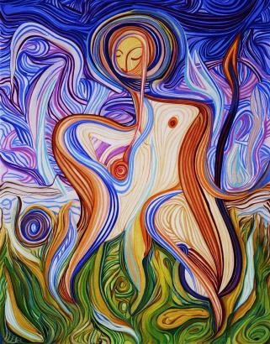

Beyond the frontier where borders blur into unknown thoughts there is a nameless boy— a drop of pure human light.
Through narrow cracks in the splintered fence I watch his innocence with envy, searching for the right meaning of his movements. The twilight of his smile nourishes my heart like crumbs of God’s light. A longing in my mouth to speak, to weep, and gather this child into my arms and encipher his nature into mine. Through the exchange of eyes glances, purloined and routed into blindness, our language annulled. I can only grope towards him with antenna thoughts that dance in praise of his youthful beauty.

I am waiting for stones to bloom.
For venomous skies to wander into oblivion.
For tracks to emerge like dust in a beam of light.

Life’s clever poison is closing the gate. The cracks are mended; the vision expunged.
And the nameless boy dissolves, for there was no earth inside him.

Chamber 14: Empyrean

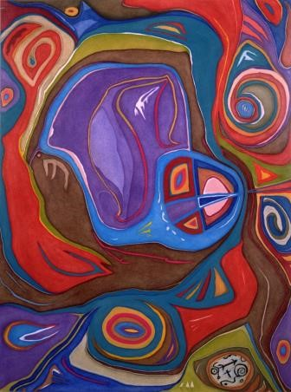

He walked a higher ground like a soul untethered to human flesh. Darkness implored demanded his searching stop and match the drifting gait of others. But his pathway unwound like a ball of string
sent upward only to fall in a sentence of light. Collisions with fate would unrail him and send him the wishes of obscurity.
The lightning of desire.
The curse of empty dreams.
The witness to unspeakable horrors.

He would laugh at the absurdity, yet aware of the dark ripples that touched him.
Humanity was a creaseless sheet of blank paper waiting to be colored and crumpled into pieces of prey for the beast-hunter.
Why did they wait?
The palette was for their taking.
The “distance” betrayed them. The shallow grave of the deep heart killed their faith.

He knew, yet could not form the words.
Nor draw the map. The ancient casts of the empyrean withstood definition. Paradise lost to the soundless blanket of the clearest thought, of the loneliest mind.

Chamber 15: Secret Language

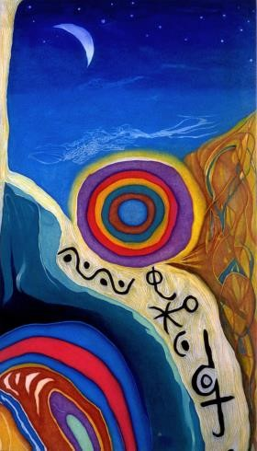

Night in bed, eyes closed, ears open, listening to the secret life outside my window. The liturgy of the nocturnal. Sounds and rhythms of swift-footed crickets giving testimony to the trees that overlook the native church like great archways carved of Roman hands.

The intricate language of tiny animals sweeping through the night air unfaltering they hold me spellbound.
How can I sleep without an interpreter?
If only I knew what they were saying.
I could sleep again.

Ancient Arrow

Chamber 16: Signals to Her Heart

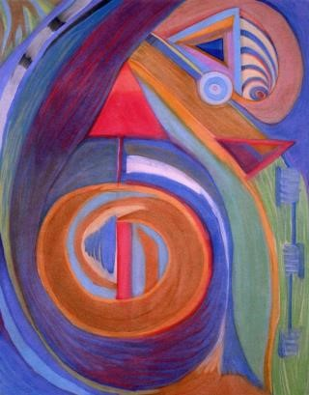

Out where the ocean beats its calm thunder against grainy shores of quartz and sand, she strolls, hands pocketed in a flowing gown of pearl-like luminance.
I can see her with hair the color of sky’s deepest night when it whispers to the sun’s widow to masquerade as the sickle’s light.

This is she.
The one who knows me as I am though untouched is my skin. The world from which she steps pounces from mystery, announces her calm beauty like a willow tree bent to still waters.

In this unhurt place she takes her body to the shoreline listening for sounds beneath the waves that tell her what to do.
How great is her dream?
Will it take her across the sea?
Does she hear my heart’s voice before the translation?

She scoops some sand with her sculpted hands and like an hourglass the particles fall having borrowed time or a chance to touch her beauty. Her lips move with prayers of grace as she tells the wind her story; even the clouds gather overhead to listen. Her gestures multiply me with the sign of infinity, disentangled from all calculations, adorning her face with a poetry of tears.

I am summoned by her voice so clear it startles me.
I watch her because I can.
I know her because she is me.
I desire her because she is not me.

In all my movement, in the vast search for something that will complete me, I have found her on this shoreline, her faint footprints, signatures of perfection that embarrass time with their fleeting nature. I am like the cave behind her watching from darkness, hollowed from tortured waves into a vault that yearns to say what she cannot resist. A language so pure it releases itself from my mouth like long-held captives finally ushered to their home.

She turns her head and looks past me as if I were a ghost unseen, yet I know she sees my deepest light. I know the ocean is no boundary to her love. She is waiting for the final path to my heart to become clear. And I am waiting for something deep inside to take my empty hands and fill them with her face so I can know the rehearsals were numbered,
and all the splinters were signals to her heart.

Ancient Arrow

Chamber 17: Memories Unbound

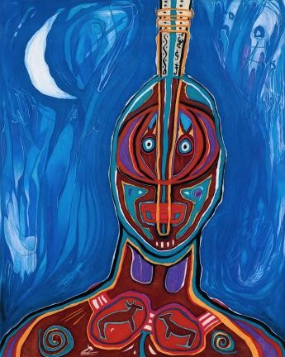

I have this memory of lying atop a scaffold of tree limbs staring out to the black, summer blanket that warms the night air. I can smell cedar burning in the distance and hear muted voices praying in song and drum. I cannot lift my body or turn my head. I am conscious of bone and muscle but they are not conscious of me. They are dreaming while I am caught in a web of exemptible time.

My mind is restless to move on. To leave this starlit grave site and dance with my people around huge fires crackling with nervous light. To join hand with hand to the rhythm of drums pounding their soft thunder in monotone commandments to live.

I can only stare up at the sky watching, listening, waiting for something to come and set me free from this mournful site. To gather me up in arms of mercy into the oblivion of Heaven’s pod. I listen for the sound of my breath but only the music of my people can be heard.
I look for the movement of my hands but only wisps of clouds and crescent light move against raven’s wings.

Sometimes when this memory peeks through my skin it purges the shoreward view. It imposes on the known predicament with a turbulent bliss that bleeds defiance to the order. There is certain danger in the heritable ways of my people who send me the chatoyant skin humbled and circumscribed. My white appetite leached of earthly rations. Misplaced to the darshan of the devil, the very same that maneuvered my people to reservations ñ the ward of the damned.
(At least I have no memories of a reservation).

Perhaps it is better to lay upon this mattress of sticks with my wardrobe of feathers and skins chanting in the wind. Perhaps it would be better still to be set atop the cry shed and burned so prodigal memories would have no home to return to.

I have this memory of escaping the pale hand of my master that feeds me scraps of lies and moldy bread. My skin yearns for lightness, but it is the rope that obliges.

I have this memory of holding yellow fingers, large and round, dripping with ancient legacies. Of seeing the rounded belly of Buddha smiling underneath a pastoral face in temples that lean against a tempest sky. I have this memory of dreaming to fly.
Stretching out wings that are newly attached with string-like permanence only to fall in the blunted arms of obscurity.

I have this memory of seeing my face in a mirror that reflects a stranger’s mind and soul. Knowing it to be mine, I looked away afraid it would become me alone.
I am patchwork memories searching for a nucleus.
I am lost words echoing in still canyons. I am a light wave that found itself darting to earth unsheathed seeking cover in human skin.

Chamber 18: Transparent Things

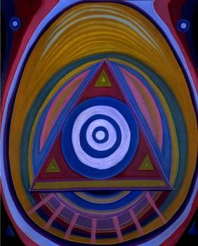

There it is then, my open wound, eager for forgiveness. It comes with age like brown spots and silver hair.
Shouldn’t age bring more than different colors to adorn the body?
I think it was meant to.
It just forgot.
Old age does that you know.
Too many things to remember here. Both worlds demanding so much, one to learn, one to remember.

Can’t we see each other without wounds bearing grief?

There it is then, my hope for you to find me and apply yourself like a poultice to my wounds.
The rest of me is barren too. Waiting for your arrival with speed built of powerful engines that groan loud from a piercing foot. Downward pressure never stopping even when floorboards are found.

If there was silence in these waters my wound would dance open and separate itself from all attackers.
Even this body. It would look at you
in the orphaning light, diminished of features, and lead you away to its place of sorrow. It would ask you to lie down beside it and wave goodbye
to the coiled currents that tug and pull to separate us from ourselves. It would hold your hands, so masterful in their wisdom, so mindful of their glory that it would disappear inside. In the future, someone, a friend perhaps, would read your palm and notice a small line veering off in a ragged ambush. Unchained from the rest of your palm’s symmetry. A lonely fragment, waving goodbye to everything between us.

There it is then, my prayer for you to close this wound and draw the shades around us. Deep, black solitude enfolding us, the kind found only in caves that have shut out light for the growing of delicate, transparent things.

Chamber 19: Easy to Find

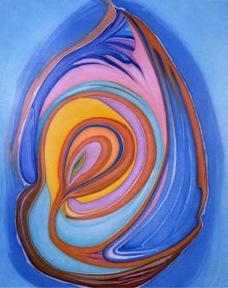

I have often looked inside my drawers without knowing why. Something called out. Seek me and you shall find, but when I obey
I’m confounded by memory’s fleeting ways. Hands immerse and return awkwardly empty
like a runaway child when no one came after them.

I know there is something I seek that hides from me so I can’t think about what I lack. It is, however, and this is the point, too damn powerful to be silent and still. Besides, I know I lack it because I miss it.

I miss it.
Whatever “it” is.
Whatever I need it to be, it is not that.
It can never be anything but what it is. And so I search in drawers and closets absent of why, driven like a machine whose switch has been thrown just because it can.

I miss it.
I wish it could find me.
Maybe I need to stay put long enough for it to do so.
Now there’s a switch. Let the powerful “it” seek me out. But for how long must I wait?
And how will I recognize it should it find me?

There must be names
for this condition that end in phobia.
Damn, I hate that suffix. It all starts with a sense of wonder and ends in a sense of emptiness. God, I wish you could find me here.
I’ll tuck myself in a little drawer right out in the open.
I won’t bury myself under incidentals.
I’ll be right on top. Easy to find.
Do you need me for anything? I hope so,
because I need you for everything.

Chamber 20: Bullets and Light

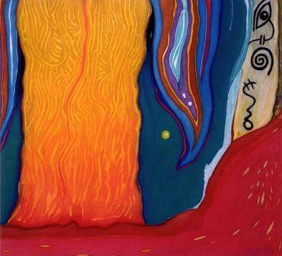

I am adrift tonight as though a privilege denied is the passageway to keep body and soul together. You have kept so much at bay I wonder if your enchantment is to tame passion. Cornered by your savage artillery you sling your bullets like schools of fish darting to a feast, and I surge ahead tired of being the food.
When I look back I can see fragments of you hiding in the underbrush, stubborn remnants of your vanished heart.
I can still love them. I can still hold their fragile nerves clustered with a welder’s tongue seething light as pure as any ever beheld.

Perhaps I drift away because of the chasm I see.
Bullets and light.
How strange bedfellows can be. But you will never confess nor shed your doubt of me. I will always remain an enigma hurling itself like litter across your absolute path. A sudden shaft of light
that begets a deep shadow that temporarily blinds.

Hope-stirred eyes have always sought to steal you from the simian nature that collects at your feet and pulls at you like derelict children.
My unearthly hunger drew me away from you, even against my will, or at least my conscious will. There was always something calculating the distance between us. Some cosmic abacus shuffling sums of bullets and light looking for the ledger’s balance, but never quite locating its exact frequency.

Chamber 21: Dream Wanderer

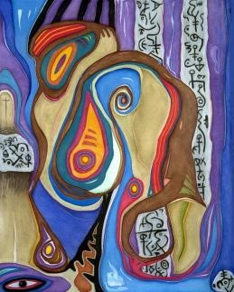

Intoxicated with children’s thoughts I wonder, why are souls so deep and men so blind? How can souls be eclipsed by such tiny minds?
Do we love the damp passageways of Hell? Where every drop of pale water that falls from the cavern walls is unwashed music etched in silence...

My favored dreams have disappeared astride the backs of eagles.
With wings sweeping downward, lifting upward, they are carried away like finespun,
elegant seeds on a crystalline wind. Without them I am divinely barren like an empty vessel denied its purpose. I can only stare into the silence ever listening for heaven’s murmur. Knowing that behind the darkening mist angels are building shelters for human innocence. Shelters torn from something dark and gravely wounded.
Havens resistant to all disease.

I thought I was endowed with a promised beauty that would free the neglected dreams of a demigod.
That would untie their feeble knots and release them into light’s caress. But the glorious reins that had once been mine, tattered and stained with blood, have slipped from my hands in disuse as a web abandoned to a ghostly wind.
I can still reach them.
I can feel their shadow across my hands. Their power, like an electric storm wandering aimlessly without fuel, soon to be exhausted.

This piece of paper is torn from something dark and gravely wounded.
It is the mirror I hold up to the blackened sky.
A devious sacrifice.

Leaping from star to star my eyes weave a constellation. My thoughts in search of the endless motherload. My heart listening for the sound of unstained children dreaming.
The dream wanderer looks back at me. Calls my name in a whispered voice.
Beckons me with an outstretched wing.

“Fly! Your favored dreams await you!”

The voice boomed like thunder swearing. My wings trembled with forbidden power as they searched the wind’s current for signs of release. Currents that would carry me to the high branches of trees suckling the sun in fields beyond my kingdom.

In a moment’s interlude I unfolded my wings and vaulted skyward, into the blue vestibule.
Sheer speed.
Rivers beneath were brown veins swollen on earth’s legs,

or savage cuts that bled green. The sun sliced holes in the clouds with tender spears of crimson light. The moon was rising in the eastern sky— an oyster shell pitted by time. Lonely winds would rush by searching for an outpost of stillness. The earthen dungeon peered up at me with contempt like a nursemaid relieved of her duty.

I forgot the ground.
I canceled gravity.
Balanced against aboriginal hopes and fears I became the shaman who dances in the spirit waters of ancestors plucking words and meanings from the cumbrous air.

I thought only of the dream wanderer...
the holy wind that rekindles my exquisite longing for raw truth. To seize it like medicine in a sleepless fever hoping to be healed.
The halcyon spire!
The dusty places of purity.

These wings are torn from something dark and gravely wounded. They carry me to my favored dreams and choke the inertia of indifference dead. Their strength is perfectly matched to my destination. One more mile beyond these trees, I would fall like a fumbled star into the moat of a starving world.

My favored dreams will wander again.
In time they will soar to trees of a richer kingdom. My wings will again follow their flight, track their heartbeat and build a quilt of a thousand dreams intermingled.
One more turn of the infinite circle.
The dream slate revivified.
Navigable— even in the murky waters and cloudy skies of the itinerant traveler. The dream wanderer reveals
(with a flip of the hourglass of heaven),
as above so below.
Create your world and let it go forward entrusted to the one that is all. The leavening will prevail. It is the lesson I learned with my wings outstretched beneath the glaring sky. It is the rawness I seek untouched by another’s polish.

Chamber 22: In the Kindness of Sleep

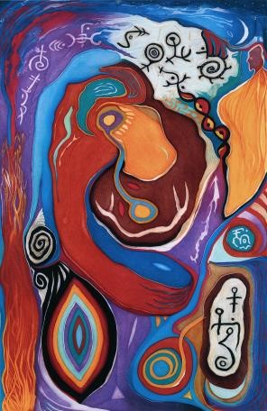

I visited you last night when you were sleeping with a child’s abandon. Curled so casual in sheets inlaid by your beauty. I held my hand to your face and touched as gently as I know how so you could linger with your dreams. I heard soft murmurs that only angels make when they listen to their home. So I drew my hand away uneasy that I might wake you even as gentle as I was.

But you stayed with your dreams and I watched as they found their way to you in the kindness of sleep.
And I dreamed that I was an echo of your body curled beside you like a fortune hunter who finally found his gold. I nearly wept at the sound of your breath, but I stayed quiet as a winter lake, and bit my lip to ensure I wouldn’t be detected.

I didn’t want to intrude so I set my dream aside and I gently pulled your hand from underneath the covers to hold. A hand whose entry into flesh must have been the lure that brought me here.
And as I hold it
I remember why I came to feel your pulse and the beating of your heart in deep slumber. And I remember why I came in the kindness of sleep— to hold your hand, touch your face and listen to the soft breathing of an angel, curled so casual in sheets inlaid by your beauty.

Chamber 23: Spiral

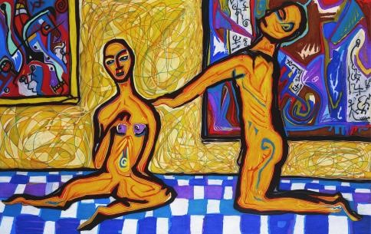

Inside there is something gnawing with silken jaws and wax teeth. It holds me still in pureness like a circle whose middle is my cage.

While you went away from me I was ever tightening my circle. A spiral cut in glass.
A flower’s bloom dropping petals. A winnowed ball of yarn spilling color.

I see the inside of your thigh brilliant in its smoothness, and I spiral ever closer to your edge. Paper cut touching I burn bleeding without pain. How could I spill so easily without knowing why?

When I hear your voice there is no quenching this ache to hold you.
Like one who draws near and then forgets the story they came to tell,
I circle you waiting for thread’s tautness to draw us ever closer though I know not how.

The final luxury is the kiss of your boundless heart. The final beauty so pure all else limps behind blissfully in your wake. Drawing from your shadows the light of saplings lurking on the forest floor.

If I could unbutton you, take your dress down I would see a map of my universe. A phantom limb, grown from my body like wings sprouting from a chrysalis reaches for you.
It is the hand of clarity desperate for your skin so powerfully bidden as though a shimmering block of light cut from black velvet, stood before me. And all I could do was to reach out and touch it,
not knowing why, but utterly unafraid.

Chamber 24: The Pure and Perfect

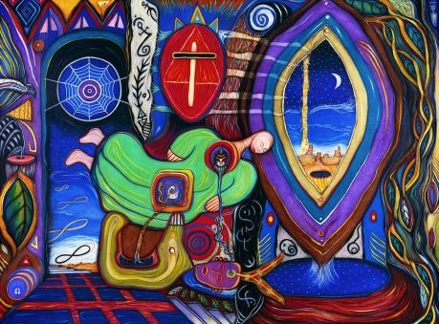

Someday the messengers will arrive with stories of a nocturnal sun despondent, burning implacably in the deepest shade of a thousand shadows. They will tell you of the serene indifference of God. They will draw you by the hand through bruised alleyways and prove the desperation of man rejected from the beauty of an unearthly realm. The news will arrive as a tribute to the death of oracles. Sparing words of purpose the messengers will announce the cold fury of realism’s cave.

Someday, the messengers will send their thoughts through books that have no pulse. You will be accused of weakness that drowns you in servitude. A queer rivalry will beset you and your life will crawl like an awkward beast that has no home.

And you, my dearest friends, who are truth—who were all along, will renew your devotion to a powerful image in a distant mirror. You will listen to these stories and tear at your silent heart
with animal claws that are dulled by the stone doors of time. Where the unattested is confirmed your vestige-soul is stored. It will strengthen you and cradle you in the light of your own vision, which will be hurled like lightning through twilight’s dull corridor.

The messengers will cry at the sound of your rejection. They will scream: “Do you want to be a
lowly servant and lonely saint?”

Mutants of the light are always tested with doubts of a swollen isolation and the promise of truth’s betrayal. Listen without hearing.
Judge without pardon.
The grand parasite of falsehood will prevail if you believe only your beliefs.

Someday, when all is clear to you— when the winds have lifted all veils and the golden auberge is the locus of our souls— you will be tested no more.
You will have reached destiny’s lodge and the toilsome replica of God is jettisoned for the pure and perfect.

Hakomi

Chamber 1: A Fire For You

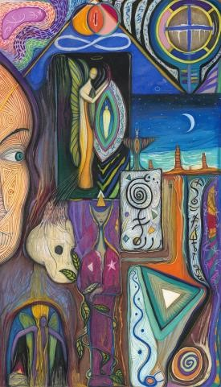

On this, the shortest day of the year, I have journeyed to the Great Plains to build a fire for you.

The night air is cold like a cellar cut from ancient stones.
But I found some wood among the deserted plains buried under the grasses and dirt, hidden away like leaves that had become the soil.
After I cleaned the wood by hand—its dirt beneath my nails and the fabric of my cloth I sent a flame combusted by the mere thought of you.
And the wood became fire.

There were hermit stars that gathered overhead to keep me company. Your spirit was there as well amidst the fire’s flames.
We laughed at the deep meaning of the sky and its spacious ways. Marveling at the fl at mirror of the plain that sends so little skyward, like the hearts of children denied a certain kind of love.

You played with spirits when you were young among these fields.
You didn’t know their names then. I was one.
Even without a name, or body, I watched your gaze, unrelenting to the things that beat between the two mirrors of the sky and plain.

I believe it was here also that you learned to speak with God.
Not in so many words as you’re now accustomed, but I’m certain that God listened to your life and gathered around your fire for warmth and meaning.
In the deserted plains he found you set apart from all things missing.

Dear spirit, I have held this vigil for so long, tending fires whose purpose I have forgotten.
I think warmth was one.
Perhaps light was another.
Perhaps hope was the strongest of these.

If ever I find you around my fire, built by hands that know your final skin, between the sheets of the sky and plain, I will remember its purpose. In barren fields that have long been deserted by the hand of man I will remember. In the deepest eye of you I will remember. In the longest night of you I will remember.

On this, the shortest day of the year, I have journeyed to the Great Plains to build a fire for you.

Chamber 2: Soul’s Photograph

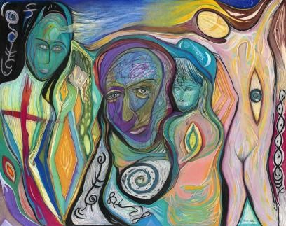

Who will find me in the morning after the winds rush over the barren body that once held me like a tree a leaf? Who will find me when mercy, tired of smiling, finally frowns in deep furrows of ancient skin?

Who will find me?
Will it be you? Perhaps it will be a cold morning with fresh prints of snow and children laughing as they lay down in the arms of angels. Perhaps it will be a warm evening when crickets play their music to the stillness of waiting stars. Perhaps it will be the light that draws me away or some sweet surrender that captures me in its golden nets.

Who will find me when I have left and cast my line in new waters trickling so near this ocean of sand?
Listen for me when I’m gone. Listen for me in poems that were formed with lips mindful of you.
You who will outlast me.
Who linger in the courage I could not find. You can see me in these words.
They are the lasting image. Soul’s photograph.

Chamber 3: Forgiver

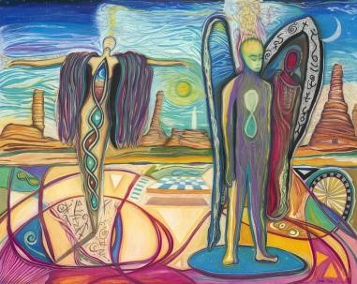

Last night we talked for hours. You cried in unstoppable sorrow, while I felt a presence carve itself into me source and savior of your dragging earth. You feel so deeply, your mind barely visible staring ahead to what the heart already knows.
I see the distance you must heal. I know your pacing heart bounded by corners that have been rounded and smoothed like a polished stone from endless waves. For all I know you are me in another body, slots where spirits reach in to throw the light interpreting dreams. Prowling for crowns.

Are there ways to find your heart
I haven’t found?
You, I will swallow without tasting first.
I don’t care the color.
Nothing could warn me away.
Nothing could diminish my love. And only if I utterly failed in kinship would you banish me.

Last night, I know I was forgiven.
You gave me that gift unknowing. I asked for forgiveness and you said it was unneeded; time shuffled everything anew and it was its own forgiver.

But I know everything not there was felt by you and transformed. It was given a new life, though inconspicuous, it wove us together to a simple, white stone lying on the ground that marks a spot of sorrow. Beneath, our union, hallowed of tiny bones beseech us to forgive ourselves and lean upon our shoulders in memory of love, not loss.

Blame settles on no one; mysterious, it moves in the calculus of God’s plan as though no one thought to refigure the numbers three to two to one.
The shape stays below the stone. We walk away,
knowing it will resettle in our limbs in our bones in our hearts in our minds in our soul.

Chamber 4: Nature of Angels

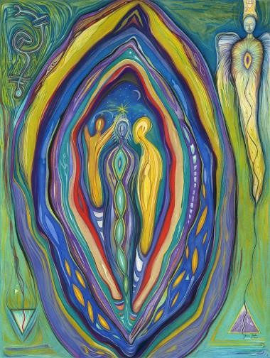

Midnight in the desert and all is well. I told myself so and so it is, or it is not,
I haven’t quite decided yet.
Never mind the coyotes’ howl or the shrinking light.

Holiness claims my tired eyes as I return the stare of stars.
They seem restless, but maybe they’re just ink blots and I’m the one who’s really restless.

There is something here that repeals me. In its abundance I am absent. So I shouted at the desert spirits, tell me your secrets or I will tell you my sorrows.

The spirits lined up quickly then.
Wings fluttering.
Hearts astir.
I heard many voices become one and it spoke to the leafless sky as a tenant to earth.

We hold no secrets.
We are simply windows to your future. Which is now and which is then is the question we answer. But you ask the question. If there is a secret we hold it is nothing emboldened by words or we would commonly speak.

I turned to the voice, what wisdom is there in that?
If words can’t express your secret wisdom, then I am deaf and you are mute and we are blind.
At least I can speak my sorrows. Again the wings fluttered and the voices stirred hoping the sorrow would not spill like blood upon the desert.

But there were no more sounds save the coyote and the owl.
And then a strange resolution suffused my sight. I felt a presence like an enormous angel carved of stone was placed behind me.
I couldn’t turn for fear its loss would spill my sorrow. But the swelling presence was too powerful to ignore
so I turned around to confront it, and there stood a trickster coyote looking at me with glass eyes painting my fire, sniffing my fear, and drawing my sorrow away in intimacy.
And I understood the nature of angels.

Chamber 5: Final Dream

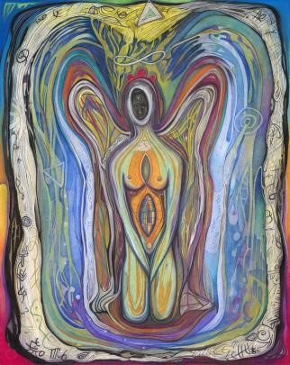

Strike the flint that burns a lonely world and opens blessed lovers to the golden grave of earth’s flame.

Listen to the incantation of raindrops as they pass from gray clouds to our mother’s doorstep. Dreams of miracles yet to come harbor in their watery husks.

Stand before this cage splashed with beauty and stealth and arranged with locks that have grown frail. A simple breath and all life is joined in the frontier.

Here is the masterpiece of creation that has emerged from the unknown in the depths of a silent Heart. Here is the laughter sought among rulers of death. Here are the brilliant colors of rainbows among the spilling reds that purge our flock. Here is the hope of forever among stone markers that stare through eyelids released of time.
Here are the songs of endless voices
among the heartless dance of invisible power.

There is an evening bell that chimes a melody so pure even mountains weep and angels lean to listen. There is a murmur of hope that sweeps aside the downcast eyes of hungry souls.

It is the fragrance of God writing poems upon the deep blue sky with pin-pricks of light and a sleepless moon. It is the calling to souls lost in the forest of a single world
to be cast, forged, and made ready for the final dream.

Chamber 6: Afterwards

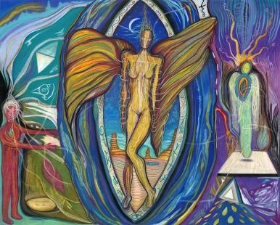

I’ve set loose the guards that stand before my door.
I’ve let cells collide in suicide until they take me. If there were stories left to tell I would hear them.

Behind the waterfalls of channeled panic spilling their prideful progeny I can stay hidden in the noise.
Being invisible has its cameo rewards. It also keeps visible the durable lifeform murmuring beneath the wickedness.
This is truly the only creature I care to know, with luminous ways of sweet generosity that suffers
in the untelling universe of the unlistening ear.

When I am found out—after I am gone— by a stranger’s heart whose drill bit is not dulled by impersonation, I will open eyes, peel away skin, awaken the heart’s coma. I will set aside the costumed figure and redress the host so its image can be seen in mirrors I set forth with words bugged by God. When these words are spoken, another ear is listening on the other side beaming understanding like lasers, their neutral light.

The common grave of courage holds us all
in the portal of singularity, the God-trail of rebeginning.

Somehow, so seldom, words and images thrust their meaning into heaven and conquer time. But when they do, they become the abracadabra of the sacred moment.
The pantomime of the public’s deepest longing.

Afterwards, the improbable eyelid glances open, the skin folds away, and the heroic eye awakens and remains alert. Afterwards, the words eat the flesh and leave behind the indigestible bitterness.
The emotional corpse shed, an insoluble loneliness. The cast of separation.

Chamber 7: Warm Presence

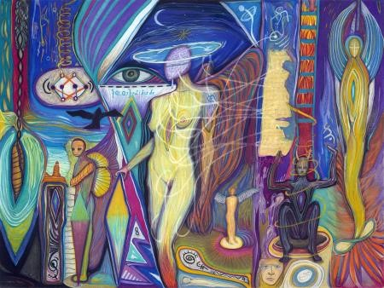

I once wore an amulet that guarded against the forceps of humanity. It kept at bay the phalanx of wolves that circled me like phantoms of Gethsemane. Phantoms that even now replay their mantra like conch shells. Coaxing me to step out and join the earthly tribe. To bare my sorrow’s spaciousness like a cottonwood’s seed to the wind.

Now I listen and watch for signals. To emerge a recluse squinting in ambivalence inscribed to tell what has been held by locks. It is all devised in the sheath of cable that connects us to Culture.
The single, black strand that portrays us to God. The DNA that commands our image and guides our natural selection of jeans.

Are there whispers of songs flickering in dark, ominous thunder?
Is there truly a sun behind this wall of monotone clouds that beats a billion hammers of light? There are small, fl at teeth that weep venom. There is an inviolate clemency in the eyes of executioners while their hands toil to kill. But there is no explanation for voyeur saints who grieve only with their eyes. There is only one path to follow when you connect your hand and eye and release the phantoms.

This poem is a shadow of my heart and my heart the shadow of my mind, which is the shadow of my soul the shadow of God.
God, a shadow of some unknown, unimaginable cluster of intelligence where galaxies are cellular in the universal body.
Are the shadows connected?
Can this vast, unknown cluster reach into this poem and assemble words that couple at a holy junction?
It is the reason I write.
Though I cannot say this junction has ever been found (at least by me).

It is more apparent that some unholy hand, pale from darkness, reaches out and casts its sorrow. Some lesser shadow or phantom positions my hand in a lonely outpost to claim some misplaced luminance.
The phantom strains to listen for songs as they whisper.
It coordinates with searching eyes.
It peels skin away to touch the soft fruit.
It welds shadows as one.

I dreamed that I found a ransom note written in God’s own hand. Written so small I could barely read its message, which said: “I have your soul, and unless you deliver— in small, unmarked poems— the sum of your sorrows, you will never
see it alive again.”

And so I write while something unknown is curling around me, irresistible to my hand, yet unseen. More phantoms from Gethsemane who honor
sorrow like professional confessors lost in their despair. I can reach sunflowers the size of moonbeams, but I cannot reach the sum of my sorrows. They elude me like ignescent stars that fall nightly outside my window.

My soul must be nervous.

The ransom is too much to pay even for a poet who explores the black strand of Culture.

Years ago I found an
Impression—like snow angels—left in tall grass by some animal, perhaps a deer or bear. When I touched it I felt the warm presence of life, not the cold radiation of crop circles. This warm energy lingers only for a moment but when it is touched it lasts forever.
And this is my fear: that the sum of my sorrows will last forever when it is touched, and even though my soul is returned unharmed, I will remember the cold radiation and not the warm presence of life.

Now I weep when children sing and burrow their warm presence into my heart. Now I feel God adjourned by the source of shadows.
Now I feel the pull of a bridle, breaking me like a wild horse turned suddenly submissive. I cannot fight the phantoms or control them or turn them away. They prod at me as if a lava stream should continue on into the cold night air and never tire of movement.
Never cease its search for the perfect place to be a sculpture.
An anonymous feature of the gray landscape.

If ever I find the sum of my sorrows I hope it is at the bridgetower where I can see both ways before I cross over.
Where I can see forgeries like a crisp mirage and throw off my bridle. I will need to be wild when I face it. I will need to look into its unnameable light and unravel all the shadows interlocked like paper dolls and cut from a multiverse of experience. To let them surround me
and in one resounding chorus confer their epiphany so I can hand over the ransom and reclaim my soul.

When all my sorrows are gathered round in an unbroken ring I will stare them down. Behind them waits a second ring, larger still and far more powerful.
It is the ring of life’s warm presence when sorrows have passed underneath the shadows’ source
and transform like the dull chrysalis that bears iridescent angels.

Hakomi

Chamber 8: My Son

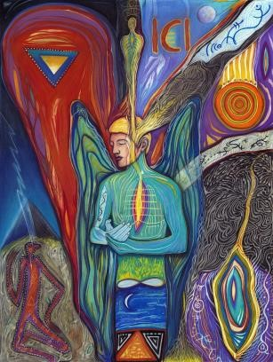

My son is two. I watch him walk like a drunken prince. With his body bare I can see his soul better. His shoulder blades gesture like vestiges of wings. His features stenciled upon pale flesh by hands that have been before me.

He so wants to be like me. His every movement like a dusty mirror or awkward shadow of a bird in flight.
Every sound an echo heard.
Every cell pregnant with my urges. But my urge is to be like him.
To return to childhood’s safe embrace and certain honor.

If I return to this place
I hope my eyes will look again upon his face even until his blades are wings once more. Until I have circled his creaturehood and know every hidden cleft where I have left my print indelible unable to be consumed.
Until all that he is
is in me and our hands are clasped, forged, entwined, in voiceless celebration.

Until we are alone like two leaves shimmering high above a treeless landscape never to land.

Chamber 9: Wishing Light

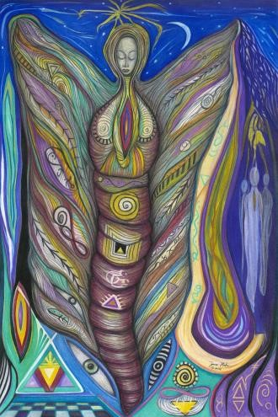

Sun walks the roof of the sky with a turtle’s patience.
Circling endlessly amidst the black passage of arrival and retreat. Moon can shape shift and puncture the confident darkness. The weaker sister of sun it bleeds light even as it dwindles to a fissure of fluorescence.
Black sky like a monk’s hood draped over stars with squinted eyes. Stewards lost, exiled to overspread the dark lair of the zodiac. This silent outback where light is uprooted and cast aside beats like a tired clock uneven. It dreams of sunlight passing so it can follow like a parasite. Tired of meandering in absence it wants to live the speed of light and feel its directness. Wishing to stay alive in light years and not some recumbent eternity. Desiring the sharp pain of life to the dull, numbing outskirts of ancient space. Darkness follows light like a tireless
wind that pours over tumbleweeds. But it always seems to outlast the people if not the light.

Chamber 10: Nothing Matters

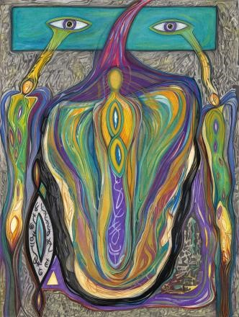

Space is curved so no elevator can slither to its stars. Time is a spindle of the present that spins the past and future away. Energy is an imperishable force so permanence can be felt.
Matter flings itself to the universe, perfectly pitiless in its betrayal of soul.

You can only take away what has been given you.

Have you not called the ravens the foulest of birds?
Is their matter and energy so different than ours?
Are we not under the same sky?
Is their blood not red?
Their mouth pink, too?

Molten thoughts, so hot they fuse space and time, sing their prophecies of discontent. Listen to their songs in the channels of air that curl overhead like temporary tattoos of light’s shimmering ways.

Am I merely a witness of the betrayal?
Where are you who are cast to see?
How have you been hidden from me?
Is there a splinter that carries you to the whole?

If I can speak your names
and take your hands so gentle you would not see me, feeling only the warm passage of time and the tremor of your spine moving you to weep.

Space is curved so I must bend.
Time is a spindle so I must resolve its center.
Energy, an imperishable force I must ride.
And matter, so pitiless I refuse to be betrayed.

So I stand naked to the coldest wind and ask it to carve out an island in my soul in honor of you who stand beside me in silence.
Lonely, I live on this island assured of one thing:
that of space, time, energy, and matter; nothing matters. Yet when I think of you in the cobwebbed corner, hove led without wings like a seed planted beneath a dead tree stump, I know you are watching with new galaxies wild in your breast. I know you are listening to the lidded screams smiling their awkward trust. All I ask of you is to throw me a rope sometimes so I can feel the permanence of your heart.

It’s all I need
in the face of nothing matters.

Chamber 11: Arrival

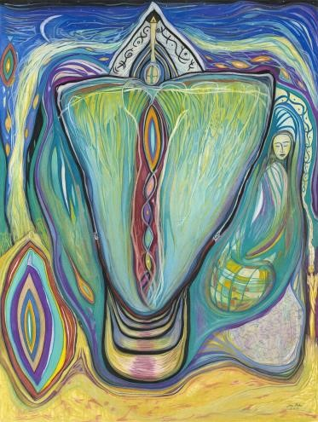

I have held a vigil for lucidity out in the horizonless fields where nothing shines
but the light of my fire and the silver disk of the endless night.

Suddenly, it’s clear that I’m alone in the wilderness without human eyes to reach in to. Alone with my treasure of sounds in the pure silence of arrival.

Hakomi

Chamber 12: Awake and Waiting

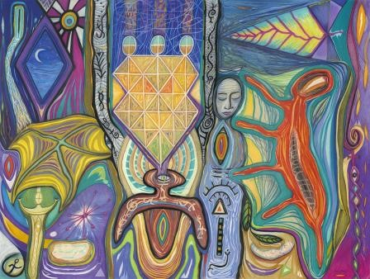

Child-like universe emerging from darkness, you belong to others not I. My home is elsewhere beyond the sky where light pollinates the fragile borders and gathers the husk. In the quiet of the desert floor my shell lingers in the pallid dusk of a starved garden.
What holds me to this wasteland when others clamor for shadows and resist the vital waters? Where the ripening magnet holds us blind.

Far away, kindling the presence of a timeless world hunting for memories of a radiant love; wingless creatures tune their hearts to the key of silence.
It is there I am waiting.
Alone.

O’ Paradise shore give me the heart to bear.
Give me the lamp that sings at night.
Give me the wings to strive against wind.
Give me the smile to translate life into light.

Time obliterates the human moment.

No one is absolved while beauty burns to charred ash too frail to last too secret to call. I will see clearly again past lives coarsened by time’s reign. My light will retake its wings; its evergreen roots will embrace the sane earth once again. And this tiny fragment, spinning in silence among giant orbs unseen
will resolve my soul and help me find the one heart awake and waiting.
Hakomi

Chamber 13: What is Found Here

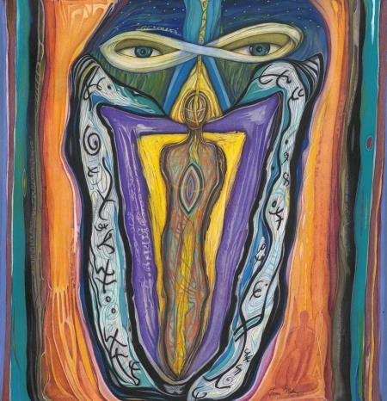

What is found here can never be formed of words. Pure forces that mingle uncompared. Like dreams unspoken when first awoken by a sad light.

What is found here can limp with one foot on the curb and the other on the pavement in some uneven gait waiting to be hidden in laughter.

What is found here can open the swift drifting of curtains held in mountain winds when long shadows tumble across like juries of the night.

What is found here can always be held in glistening eyes.
Turned by silence’s tool of patience. Like feelings harbored for so long
the starward view has been lost.

Hakomi

Chamber 14: Forever

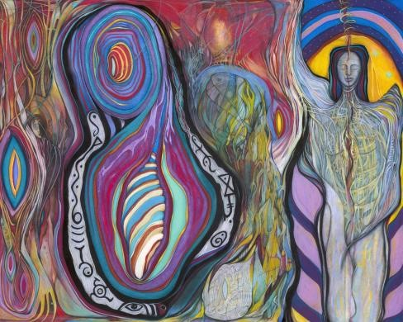

Memory, like a root in darkness, piercing light with its stem has found me. Ordering my world like architecture of feelings bound to you, held for you as shields of hope. In the dispersion of love, identical throbbing has been our call answered in the sweetest caress two can share.
And you wonder if ecstasy will diminish us
like rain the sun or wind the calm. When we know one another in the deepest channel of our hearts we can only utter one word cast from this stone’s mind: forever. Forever.

When winter calls my name in the highest desert of light, I will not despair because I know you in the deepest channel of my heart where I understand the word, forever. Instantly healed by your caressing lips that unmasks all that has tortured me. The panting of mouths
tired but astir in passion’s flame can only cease when I have entered you forever.
I carry you in this flame, emerald-colored from my dreams of you beneath the trees within where your beauty consumed the sun and snared my soul so completely. I cannot truly know you apart from a throne.

Spirits made to shine beyond the din of boorish poets that strike flint below water and cry without passion. I have known you forever in lonely streets and the thundered plain.
In wilted villages and cool mountain terraces. I have watched all of you torn open to me speaking like a river that moves on forever. And I have waited like the greedy mouth of an ocean drawing you nearer to my lips so I can know you forever as you empty into me abandoned of all fear.

Hakomi

Chamber 15: Longing

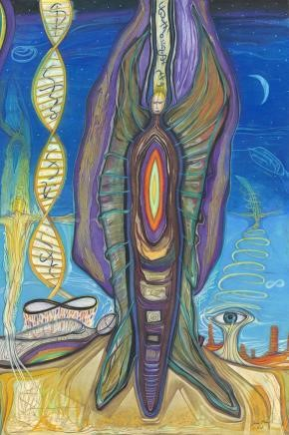

Longing, when the eyelids open upon the deepest stimulus held by your lips and the amorous kiss becomes my orbit.

I ache and long to have you with me so close our skin would melt together like two candle wicks sharing wax. I only know that what is of soul is of longing and ache. It delivers me to the edge, the precipice where I look down and see myself inextinguishable, longing to be consumed by you.

And in that glittering place let me stretch with your heart at full speed, blind and intent. Let me dwell in you until I am so familiar with our union that it becomes part of my eyes. With memory full, we can walk home, hand-in-hand, in the permanence of longing.

So much a part of the other that the other does not exist.

Hakomi

Chamber 16: Song of Whales

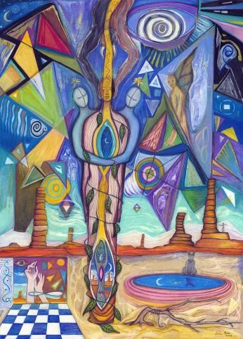

Your voice lingers when it speaks like rippling heat over desert floor. It draws my heart and I find myself leaning toward its source as though I know it will take me where you always are.
It draws me near to your breath—the spiracle that holds the words of home.

It draws me to the blanket you hold around your soul you so willingly share. If you were to dive below the waters where the whales sing their songs into the gathering of deep currents that pull our courage along, channels that flow free of worldly levels, you would find me there. Listening to the voice I hear in you. Feeding my heart in the waters of deep blindness where currents flow mindful of you and your spirited ways.

Sometimes I listen so perfectly I hear your soft breath forming words before they are found by you. Before you can bring them from the deep blindness to your heart.

I wish I could take your hand and let it hold my heart so you could see what I know of you. So you could know where we live where we always are. And you could pull your blanket of words around us and I could simply listen to your voice that honors words like the songs of whales.

Chamber 17: Imperishable

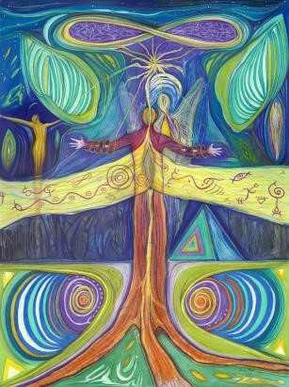

Through this night I have slept little. My eyes, closed like shutters with slats that remain open, wait to invent dreams of some charred reality. I sense you, but no weight on my bed. No shift or creaking other than my own restlessness.

Wandering words self-gathered, self-formed, and released to the night like a mantra slowly drowned in music. Your presence grew with the music devouring it in silence. You came to me so clear my senses aroused in electric storms of clarity. The buzz of mercury lamps alongside rutted roads, shedding their weightless light.

In all of this waiting for you no fortress or foxhole bears my name. I lay on the Savannah staring at the sun hoping against hope it blinks before I do. My wounded cells, tiny temples of our mixture,
have weakened in your absence. I can feel them wail in their miniature worlds. My feet resist their numbness, deny them their war.

As I lay here alone
waiting to be gathered into your arms, I ask of you one thing, remember me as this. Remember me as one who loves you beyond yourself.
Who pierces shells, armor, masks, and everything protecting your spirit in needless fervor.
Remember me as this. As one who loves you unmatched by the deepest channels that have ever been forged. Who will love you anywhere and always.

And if you look very closely at my love
you will not find an expiration date, but instead, the word, imperishable.

Chamber 18: Another

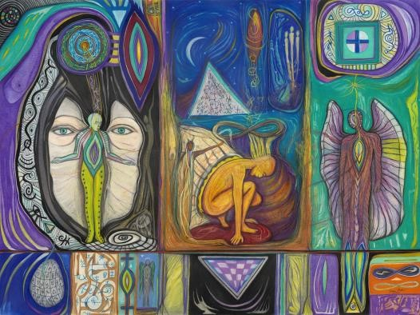

One skin may hide another, I remember this from a poem when I launched a fire across a field of deadness. At least, to me, it seemed dead. I felt like a liberator of life force renewing the blistered and dying grasses. Actually, more weeds than grass, but nonetheless, the flora had flat-lined. I peeled back skin with holy flame and brought everything to black again as though I called the night to descend. From blackness will arise a new skin cresting green architecture from a fertile void.

As the flames spread their inviolable enchantment I saw your face spreading across my mind.
Remember the fire we held? I hoped it would unfurl a new skin for us as well. Forever it will roam inside me invariant to all transformations and motions.
(Einstein smiling.)
One person may hide another, but behind you, love is molting a thicker skin than I can see through.
No flame can touch its center.
No eyes can browse its memory.
I want nothing behind you in wait.
Seconds tick away like children growing in between photographs. I will not forget you in the changes. Cursed with memory so fine I can trace your palm.
I can inhale your sweet breath.
I can linger in your arms’ weight. I can hear your exquisite voice calibrate life with celestial precision.

One purpose may hide another. I heard this as the fire died out to reveal the scent of the wet earth and growing things. I could feel my love decompose returning to the uninhabited realm where it belongs. Where all hearts belong when love is lost, and the code of the mute, coiled in fists that pound, reveal the wisdom of another.

Chamber 19: Missing

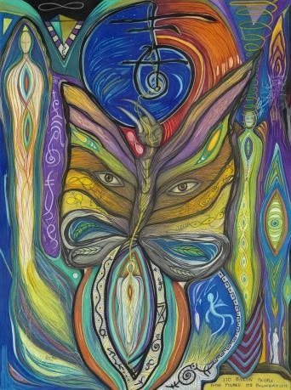

Facing another evening without you I am torn from myself in movements of clouds, movements of earth spinning like the sure movement of lava as it rolls to sea. Yet when I arrive from my dream you are still gone from me twenty-three footsteps away; a bouquet of the abyss.

When I look to the east I think of you softly waiting for me to chisel you from the matrix with smooth hammer strokes from my hands.
Freed of barren, untouched shoulders, you can open your eyes again flashing the iridescent animals, valiant vibrations of your rich spirit.

Your picture is the centerpiece of my table I stare at you in candlelight, the windows behind, black in their immensity, only enlarge you. Making you more of what I miss.

At night I go among your body
to feel the presence of your heart beating
something golden spun from another world. You can feel me when this is done though I am invisible in all ways to you, but one.
A reflection in the mirror. Beneath your eyes you see me dancing away the body.
Dancing away the mind. Dancing away the incarnations of my absence.

Chamber 20: Half Mine

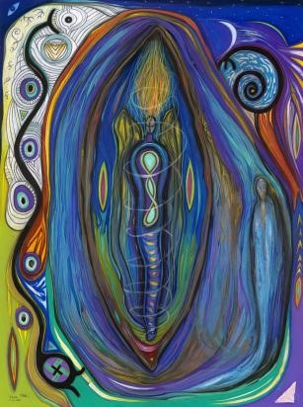

When I see your face I know you are half mine separated by the utmost care to remember all of you. When I undress my body I see that I am half yours blurred by sudden flight that leaves the eye wondering what angels carved in their hearts to remind them so vividly of their home.

When I see your beauty I know you are half mine never to be held in a polished mirror knowing the faithful hunger of our soul. When I watch your eyes I know they are half mine tracing a trajectory where sensual virtue is the very spine of us. When I hold your hand I know it is half mine wintered in kinship, it circles tenderness beneath the moon and well of water when the feast is done. When I kiss your lips I know they are half mine sent by God’s genealogy to uncover us in the delicious cauldron of our united breath.

When I hear you cry I know your loneliness is half mine so deep the interior that we are lost outside yearning to give ourselves away like a promise made before the asking. And when I look to your past I know it is half mine running to the chokecherry trees invisible to the entire universe we found ourselves laughing in sudden flight eyeing the carved initials in our hearts.
Sparing the trees.

Chamber 21: Language of Innocence

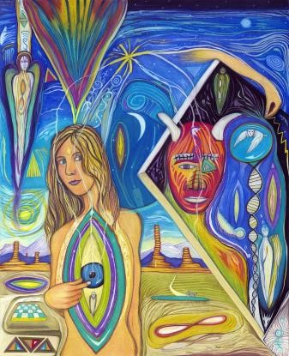

When a river is frozen, underneath remains a current. When the sky is absent of color beneath the globe another world comes to light. When my heart is alone somewhere another heart beats my name in code that only paradise can hear.

Is my heart deaf or is there no one who can speak the language of innocence? Innocence, when words suffer meaning and gallop away in its presence.
I have seen it.
Felt it.
I have loosened its secrets in the blushing skin when upturned eyes witness its home and never turn away. And never turn away.

There is this world of slumbering hearts and hollow love, but it cannot carry me to daylight. My craving is so different and it can never be turned away.

Hakomi

Chamber 22: Compassion

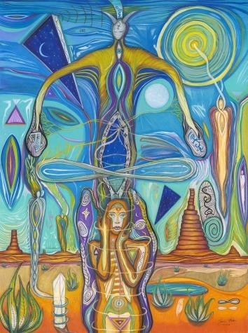

Angels must be confused by war. Both sides praying for protection, yet someone always gets hurt.
Someone dies.
Someone cries so deep they lose their watery state.

Angels must be confused by war.
Who can they help?
Who can they clarify?
Whose mercy do they cast to the merciless?
No modest scream can be heard.
No stainless pain can be felt. All is clear to angels except in war.

When I awoke to this truth it was from a dream I had last night. I saw two angels conversing in a field of children’s spirits rising like silver smoke.
The angels were fighting among themselves about which side was right and which was wrong.
Who started the conflict?

Suddenly, the angels stilled themselves like a stalled pendulum, and they shed their compassion to the rising smoke of souls who bore the watermark of war. They turned to me with those eyes
from God’s library, and all the pieces fallen were raised in unison, coupled like the breath of flames in a holy furnace.

Nothing in war comes to destruction, but the illusion of separateness. I heard this spoken so clearly I could only write it down like a forged signature. I remember the compassion, mountainous, proportioned for the universe. I think a tiny fleck still sticks to me like gossamer threads from a spider’s web.

And now, when I think of war, I flick these threads to the entire universe, hoping they stick on others as they did me. Knitting angels and animals to the filamental grace of compassion.
The reticulum of our skyward home.

Hakomi

Chamber 23: Separate Being

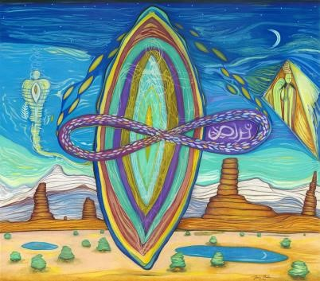

Waking this morning, I remember you. We were together last night only a thin sheet of glass between us.
Your name was not clear. I think I would recognize its sound, but my lips are numb and my tongue listless from the climb to your mouth. Your face was blurred as well, yet, like a distant god you took your heart and hand and there arose within me a separate being.

I think you were lonely once. Your only desire, to be understood, turned away by some vast shade drawn by a wisdom you had forgotten. So you sang your songs in quiet summons to God hoping their ripples would return and gather you up. Continue you. Brighten your veins and bring you the unquenchable kiss of my soul.

Drunken by a lonely name you stagger forward into my nights, into my dreams, and now into my waking.
If I try to forget you you will precede my now. I would feel your loss though I can’t say your name or remember your face. I would awaken some morning and long to feel your skin upon mine knowing not why.
Feeling the burn of our fire so clearly that names and faces
bear no meaning
like a candle flicking its light to the noonday sun.

Hakomi

Chamber 24: Beckoning Places

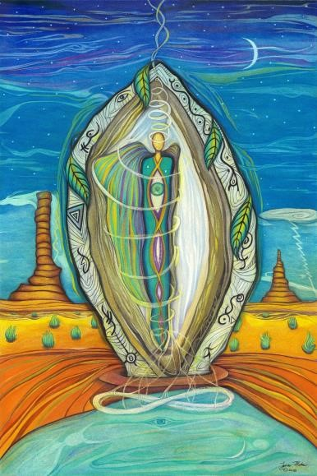

Of beckoning places
I have never felt more lost.
Nothing invites me onward.
Nothing compels my mouth to speak. In cave-like ignorance, resembling oblivion, I am soulless in sleep.
Where are you, beloved?
Do you not think I wait for you?
Do you not understand the crystal heart? Its facets like mirrors for the clouds absent of nothing blue.

Invincible heaven with downcast eyes and burning bullets of victory that peel through flesh like a hungry ax, why did you follow me?
I need an equal not a slayer.
I need a companion not a ruler.
I need love not commandments.

Of things forgotten I have never been one.
God seems to find me even in the tumbleweed when winds howl
and I become the wishbone in the hands of good and evil.
Why do they seek me out? What purpose do I serve if I cannot become visible to you?

You know, when they put animals to sleep children wait outside as the needle settles the debt of pain and age. The mother or father write a check and sign their name twice that day. They drop a watermark of tears. They smile for their children through clenched hearts beating sideways like a pendulum of time.

And I see all of this and more in myself.
A small animal whose debts are soon to be settled. Children are already appearing outside waiting for the smile of parents to reassure. The signature and watermark they never see.

Of winter sanctuary I have found only you.
Though I wait for signals to draw me from the cold
into your fire
I know they will come even though I fumble for my key.
Even though my heart is beheaded.
Even though I have only learned division. I remember you and the light above your door.

Zyanya

Chamber 1: Continuity of Consciousness

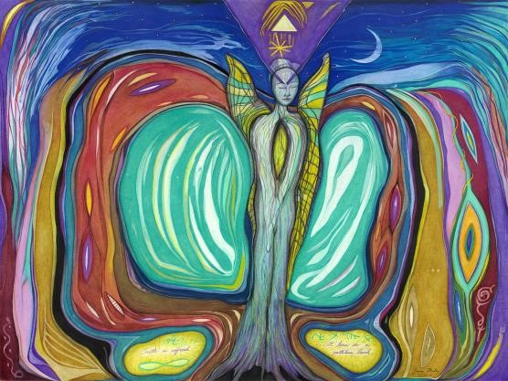

The language of life is gibberish to me now; fey, guttural ciphers scrolling bored and restive, sibilant mallets of consciousness struck on a vast timpani. The tableau lingers in an afterglow, and with a choreographer’s gift, prior to the vanishing, an actor bows briefly, pure and untainted and then walks off stage.
How can a thousand faces, properly lighted, be cold and stumbling? No applause?
The cruel silt that amends our presence persists. A timestamp assures us that as parallel spirits of a shared pigment we live in a serial time. We can pace-off the distance. We can overcome the linear, and become strangers that blot a destiny
from the common ink of implacable need. The isolate choice, a universe digging at its own scabs, unrepairable and therefore repeatable; holds us from the silences of God. Spun of faith, we are the loom that imagines
the mirror image. Despite all of this, we rise. Stillborn spirits made of vapors that seek the altitude that never ends.
The backward glance does not satisfy.
The forward stare blinds. The closed eye gathers the single photon
and over the rim, multiplies.
Zyanya

Chamber 2: The Guardian

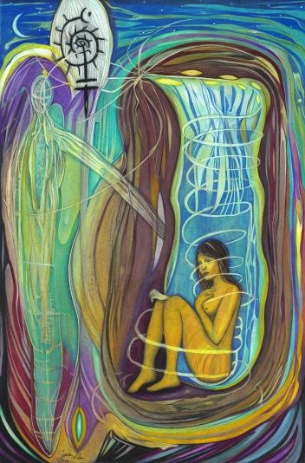

In a paralyzed moment the shift bellowed. Time crashed to the black tarmac; a pile of thrones. Tectonic plates lurched at me like celebrants of a victory march. My heart spun in the blue, viscous liquid; its centrifugal force forever separating the hopeful from the insufficient. And now, yes, just now, the minutes pool like cut stones of an ancient pyramid. Time restored, my spirit can once again spit soft, vanilla words upon the desecrate earth. Who or what intervened? A guardian forsworn to protect pilgrims from themselves?
An entrapped guard that decided -- in the winking subversion of fate -- to ever-so-slowly become me?

A deep-cast search reveals the single eye, the untethered diadem that swells in secrecy. Its mystery cloak, like counterpoints unwoven, drape like wings, and I shimmer, as it grazes my shoulder. A winged guardian steps out and I feel the countdown of self-destruction.
A compulsory step forward. A mutual stare. The stubborn arrival that cannot be withheld. Calling a name expelled from a vacuum; announcing itself like a sudden flare in the blackest night.

The guardian within the guardian, forever in contempt of court, served a hasty warning to the bought verdicts and embodied deprival. The evaporate world, slung in the compost of a universe uncharted, reveals the one name that is nontemporal. It is the name of an eternal psyche lost in a thousand-linked chain of temporal bodies.
Each chain, a guardian.
Each guardian, a wisdom-giver.
Each wisdom-giver, a god.
Each god, a universe. Each universe, a leavening of all through the cut stones of time.

The paralyzed moment, beneath the lens of the diamond core, an undying perfection unperturbed
like a spring-fed stream enters a flaming forest.
Zyanya

Chamber 3: Upon a Giant

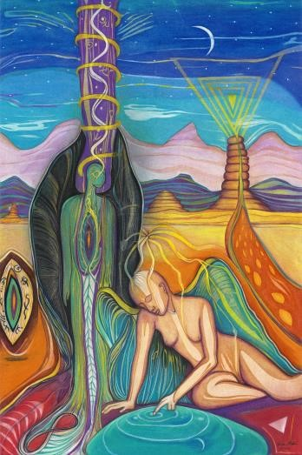

The earth cringed when I left. I heard its voice in my parting breath, a deep-scowled tone thundering atop all roofs: “Didn’t he used to live upon a giant?”

Metaphoric roles like jointed doll models prance as Fate’s seductress. Always ahead, bartering pity, deferring retribution for the insolvent touch of the black crude spirit in crusted books.

We forget the visit to god’s winery, for the memory of invertible, twisted vines and the fugue of a heaving earth.

I have learned to settle within, outside my body,
unafraid of death’s opaque cloak that falls like a slowmotion leaf in the utter stillness of a dawning forest.
The rhythm in my veins entrained to the glorious Unknown by the spirit mentors Love and Death. Lashed together like a pacemaker to a heart, parallel spirits can fly halved or not; keening tribulations unheard In the safest safe.

I cannot promise mine is yours.
I cannot see for you.
I cannot live as an adversary.
I cannot chase a finite vision.
I cannot promise you indelibility.
I cannot give you the funeral of innocence. I cannot, with pointed fingers, accuse the goliath mistake of Destiny’s puppetry. We might as well be vapors; malleable, faint, ghostly. With no points of attachment; strings fall.
Giant hands wince without resistance.

But there is a way into the centermost core. The collective psyche favors a savior, it always has it always will. The savior is the collective. It always has been and will always be. In that central serenity of permanence the feral souls flock amid the skies, chanting the primal hymns of one being.
One collective being.
One.
Collective.
Being.

I have heard this chant.
It remains aglow of purpose to draw us inward to that place unfractured, unmasked, waiting for our memory to unite.
It is all.
The pluperfect of history -- all history -- is not right or wrong, steeped in moral certitude. It is chatter in the conversation between all and One. The Attractor, the One, is not the beginning and the end, nor the beginning of the end.
It is the before and after. It is not the collective all.
It is the unified one.
The difference between is infinite
like the shadow of a universe.
Zyanya

Chamber 4: The Snake Remains

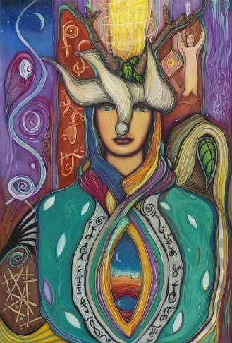

Extreme measures were required, not platitudes without the how. Hunting quarry with insults is as ancient as humanity sloughing its generational skin, but the snake remains. You can try to be the sum of all suns, like a sparkle conspiring to dazzle its diamond host, but the snake remains.

We are pronged on the wrong setting like stained glass wanderers tightly framed in gray, stone blocks. The brazen herd watches in the humming light and musty air of truth’s museum. Booming notes from a holy organ whirl about their conflicted limbs, but the snake remains.

A fire approaches herded by winds that confess that they are the only protectant from the rope’s end.
Held by choking hands, a slippage into oblivion right on the border of Elysium, so close to home, but the snake remains.

The mirror’s countenance is unchanged, a vague hereafter is dealt in equitous calm. You look at your reflection, as if prying off the lid of a paint can completes the work. When all else fails you can push forward, the onward breathing that draws life from the thin air.
Feel that magic!
The thin air!
But the snake remains.

There is a showdown long coming. The knowledge of good and evil bears shriveled fruit. Duality exhumed to resume its quarantined patch of space; and the only cannibal of note -- the ouroboros -- will dine on the flesh of time.

How do we continue to bloom when the snake remains? When holes punch through us and scatter our sight? How do we listen, just listen,
listen,
when the hissing remains and the slithering unsettles?

In some way, we are all revenants, poking through the earthen crust like seeds whose code impels the search for light. A tree falls
and no one hears its crashing reverberations. The echo persists deep below in that hollow, cavernous space we call life. We hardly notice, but the snake remains.

Chamber 5: Not Impossible

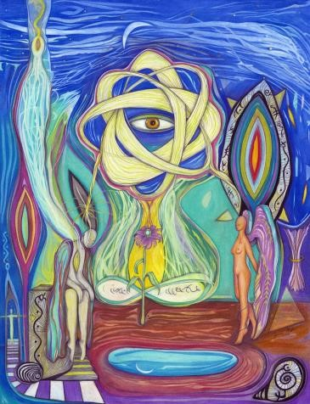

The curious wing, oblivious to its chains, flexes muscle with hammering precision, and the body rises. The tugging of chains,
finally felt, remove hope with clipped derision.

The winged creatures settle for a range, but have Icarus visions. Over and over it repeats until the range is compacted under the weight of norms, and the curious wing is made less curious.

Maps have borders. Their merciful renditions take into account the length of chain, the invested energy, the centered home.

The ganglions of separation flared their afferent paths and we followed like debris in the current of a swollen river. No map or wing is necessary. Those are for mystical lore where the blackbird priest, with his feelered hands, shames his flock. The range grows smaller.

We are captives, hidden tight in the twilight maze. What force protects us from what force?
The manacles chaff.
The wing beats tiresome.
The final story waits to be told.
Will we be there when it is?

And if home is not on our maps or in the range of our wings, then where is it?

The winnowed truth blown by a trillion breaths stands so tall as to be invisible. In wavelengths too small to divide like the print of an atom’s touch. Our mouths do not move to these rhythms and sounds.
The story is being told right now, right here.

Immaculate. Impeccable.
Imaginary.
Not, not impossible.

Chamber 6: New Prometheus

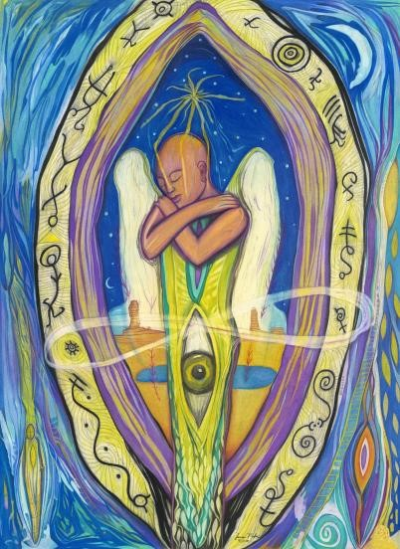

Body sees.
Emotion feels. Mind groks.
Soul is lit from a fire
we cannot see or feel or comprehend.

Faith, a flat earth, cast off from the matrix of unity. It survived by pulling the sky-curtain back and releasing the angels -- both good and bad. Our binary world rooted in righteous irrationality.

The door of no return, built by a disfigured mind that ushers final breathers to their life retrospect against the whiteboard of binary code.
There is no debugging.
There is no real release.
Only the circuitous re-entry into the cave of silhouettes.
The rehearsals staged.

Perhaps Plato suffered the disillusionment that all true mystics -- imperiled by detachment -- see, feel, and grok when they stumble upon the source of the fire.
There was never education in the binary world. It was a program. The source of the fire and the source of the program are not entangled in any manner, except one.
They are one. And it is precisely there where the disillusionment rises up on its very tiptoes, waving its arms and shouting: there is only the dance.
(Thank you, T.S. Elliot.)

The stillpoint smiles, a doppelganger of the Mona Lisa. E=MC²;
but the fire is not energy.
It is not dance.
How can such utterly opposite things be one? We need a new formula that pierces the interdimensional conclaves of weirdness (spooky, if you prefer) and bears humanity a new Prometheus.

Chamber 7: The Oasis Ahead

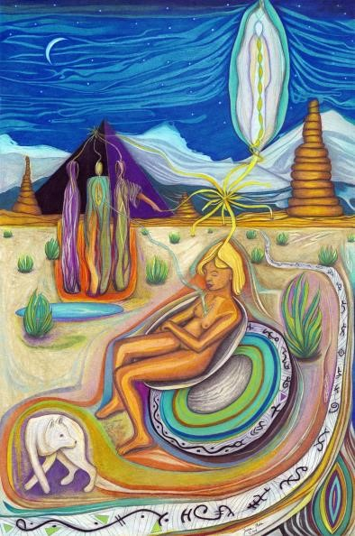

These eyes that water in the telling, drift on the edge of a stream that issues from heaven or hades,
I’m not sure.
They both have gates. To keep in or keep out; Does anyone really know?
It could be both.
The evidence is delinquent. Fiddling with levers that rise and fall at the will of vacant eyes; humans, once incandescent, now obscure light from behind the curtain. Dreams woefully mangled into wavelengths long and aimless;
boomerang to ego
like a cat at feeding time, nustling ankles.

The treasure is not out there in the restless eyeballs.
The life you thought was to be lived is to be annealed into a lump of clay and tossed onto the potter’s wheel to be reshaped, retooled, into wisdom’s golden casing. Only your hands can draw boundaries in chalk and walk across them, sated by the checkpoints behind you and the Oasis ahead.

Chamber 8: Testimony

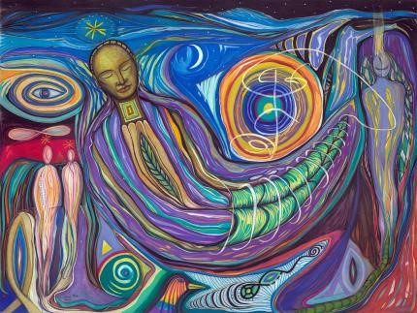

I’m sitting in a pew; a child of eight.
A deacon winces behind a lecturn as he recalls the bitter plight from which he was saved. For some reason they call it testimony.
In the deacon’s moment of salvation, when he was in the pit of despair and the hand of God reached down
to save him, he was naked.
Not even a figleaf.
(Damn and dam those Adamic themes.)

The deacon had been the victim of alcohol and nameless drugs, caught in their merciless undertow. He ended up in the fetal position on the floor of his shower (not exactly Eden), when something miraculous happened.
A voice spoke to him.
I wanted to ask, were the drugs still working? But it was church, and my father was next to me.
I didn’t want to invoke the stern lanterns or the stooping whisper.

That voice, at least to the deacon, was real.
it wasn’t his imagination, he protested,
or having been caught in the crossfire of alcohol and heroin.
No... he made that quite clear.

Instead, by a miracle’s mirage the deacon had stood to his feet, half-choking, half-baptized by water, in a birthday suit that I couldn’t help curiously imagining. The voice the deacon heard, seemed to need a capital “V”, because he had referred to it as the Voice.
It’s a funny thing to me is that god should be capitalized, as if it’s a proper noun, and any action (verb) or thing (noun) that issues from god, should also be capitalized.
No comprender.
God is not a name for a person.
Even when I was eight
I knew that god was an indefinite pronoun.

But back to the Voice.
The deacon’s cadence slowed down, his tone wrenchingly somber,
and then, he whispered the words the Voice told him
(from outside of himself, he emphasized one more time):
“Lift yourself up. You have work to do.”

Hmm, I had been properly baited,
reeled in, fileted and baked, and then this punchline?
That was the Voice? Of god?
That’s all it said?
That was what saved you?
That’s your testimony?
That was divine intervention?
For a deacon?
What about me?
Maybe the voice would say:
“Get out of bed. You have school!”

My mom said that. Regularly.
That’s my testimony.

Zyanya

Chamber 9: The Theory of Everything

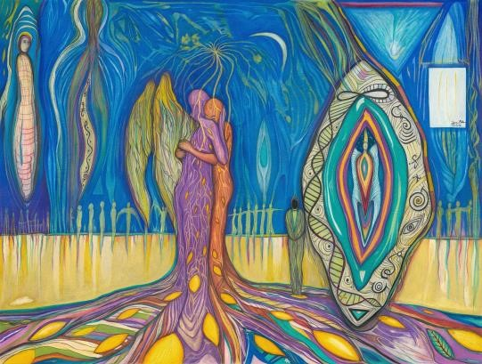

If we are to walk a tightrope with the tipani of righteousness banging out its querulous beat, we must be calm, steady, poised, impervious.

At our back, vultures crown the sky, ink blots spiraling ever-closer to stain the land. One foot out the rope cringes with the weight. Far below, a rattlesnake darts from behind gray rocks.

The theory of everything is woven upon the tightrope in code that only an ant could see. Doubtful it would illuminate the ant or any of us.
Everything?
Really?
You mean a theory for every thing in every dimension that ever existed or exists?
Do you mean the future, too?

Is there such a theory that can connect all the dots? Leave nothing out, even nothing?
I wonder where wonder would be found if such a theory materialized. Suddenly, from out of the gloom of ignorance, we looked upon our silver screens and saw the irrefutable truth of connection to everything.
Would any of us understand?
The tightrope is too high.
The net, too thin.
The code, too small.
Our minds, too thick.

When the tightrope cringes our hearts fall to fear.
Looking backwards to the wooden platform that small block of safety with a leaning ladder of Pisa. And yet, there is the pull of the other side. The jawboning parrots block the way critics of all things original, The theory of everything is the most original of all originality for the simple reason it threads everything in a single fabric.
What could be more original than that?

Zyanya

Chamber 10: One and Equal

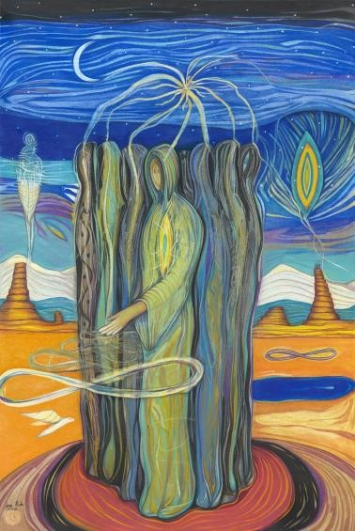

The stories you've been told have made you pray to the sky-fixer. With the weight of a ghost in space the genie spins. You lower your clasped hands to your sides and sigh. A downward glance, a broken floor, a stunted breath stuttering in the wireless world. The unequal falsehood, stood up by derelict stooges, is paper-thin, but as strong as a belief can be. Forked tongues welded these stories to your mind’s basement, the casement for the blind. What does equal mean, any way? Equality is a concept from the other side. It has not bred
on this side of the abacus. It is the orphan in the corner, the inductive murmur neutered to stand like a sculpture in empty

space.

We can see it, touch it, know it in our minds, imagine its purpose, but, like a marble eye it stares back at us, lifeless.

One and equal is the chant.
One and equal.
One and equal.
1&=.
Perhaps it is more a prayer than a chant.
Maybe an affirmation? Maybe a hope?
Certainly not a mantra.

The sky-fixer, spinning in weightlessness, waits for more voices. The franchised choir whose mercenary ways
alienate, separate, explicate, ultimately precipitate the reins that embrace you and hold you as seven and a half-billion blueprints, wandering the coagulate spirit. Garbed as particles of one thing ignorant of itself.

You pledge your fate to the invisible giant whose bowels of confusion constitute your path.
You rise up in protests, victorious with new laws, crawling to the flying goalposts of equality.

The genie sleeps. The three wishes expressed lilt on the winds of time.
They are:
ONE. Give us immortal life.
TWO. Give us freedom within that immortal life. THREE. Give us purpose. A fourth wish limped behind, whispered in a croaking breath: Give us equality. The genie scowled, its arms green and muscular,
“There are only three wishes. You cannot have more.
Do you wish to substitute?”

The particles, lost in their blueprints, collectively shook one head and crawled their separate ways.

Zyanya

Chamber 11: Our Home

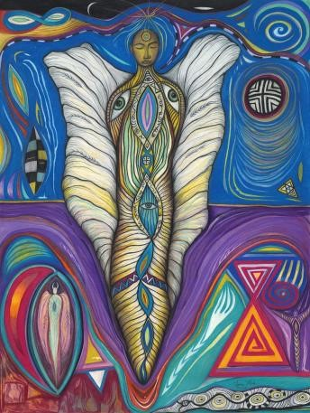

When all else fails remind me of our home. Even the word is warming.
In the back of a deep drawer I can reach blindly, fingers as eyes.

When I imagine home
I have no fingers or eyes.
Something approximate of light. Something unbounded by heaven and hell. Something free from the infectious armies that patrol the borders between black and white.

Liberation is the ultimate home. There is no border, gate, fence,
moat, wall, door, or barrier. No antibodies patrol with creeping tendrils.
No antidotes to patch poisen’s wicked pluck.

Home is cast from a matrix; a boundless source unprogrammed. A mystery billowing like a forceful form half-seen.

When all else fails let me hear the primal hymns that soar through the tall, half-naked pines. Let me feel that ecstasy when light and air expose the soul’s heartbeat, and its drumming cannot be unsummoned.

When all else fails remind me of our home. In my final depletion only speak those words:
Our home.

Chamber 12: My Quietest Voice

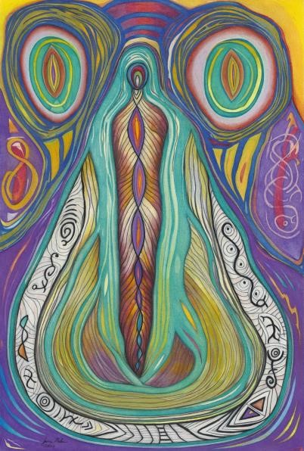

If I could speak the quietest voice of my body, I would doubtless disturb you. I would tell you of noble gestures, confounded by glamor and gain, that codified discontent. I would tell you that the search is cast in the wrong direction, because the maps were written beneath wings of steel. I would tell you that the one thing missing, that hibernates within each of us, asleep in the surrender of hope and belief,
is the proof that we are one and equal. I would tell you that this proof is not so hard to find if you are willing to live from the heart. Only there is the proof surfaced like a whale’s breath.
I would tell you that the mind is a prism that separates colors, disunites forms, and severs realities; while the heart fuses, mixes, and coheres. I would, in my very quietest voice, a voice that even an ant would strain to hear, tell you that the proof is in the heart.

Chamber 13: No Shelters

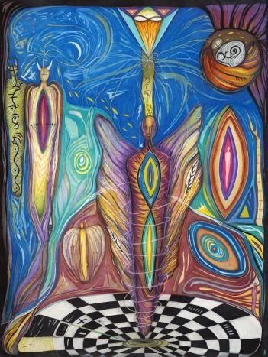

I walk a path surrounded by thorn bushes, darting from the underground; angling their way to the gleaning shelter.

Can you see this shelter?
Invisible horses herd us.
Stern voices command us.
Winnowing touches draw us closer.

Our purpose is lent from a landlord cast of clay, surfaced in gold, burnished to a sheen that blinds.

Inside the shelter, compliance of generation upon generation, hollowed out, thinned to the same themes of sin and insufficiency.

How can a shelter, based on sin and insufficiency, be a shelter?
An oasis for slaves?
A detour into the illusory?
The pull of a demonic shade?
A mirage of tarnished hope? A dream of salvation where souls are properly attired in bowing minds.

I walk a path that moves serpentine, dotted with eyes that see around bends and over mountains. That see the karmic freight borne of a listless, if not witless, mass. Whose map encircles an entire galaxy of learning where there are no shelters.

Chamber 14: Purpose Served

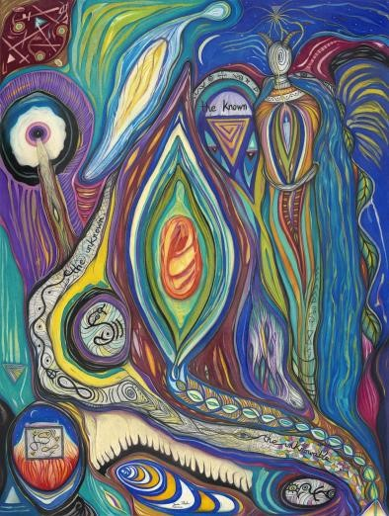

Do not be seduced by the plow of nihilism. Its seeds sprout, and nihilists believe in the sun, water and soil. They are the equal and opposite effect of something ineffable, where real, unreal, and surreal align in a magnetic clasp of surrender.

The Enlightenment obscured the ineffable, like an eclipse blunts the moon or sun. The core of light is unchanged; the program of blockage ebbs and flows through generational time.
Science will prove perennial mysticism.
The eclipse is always temporary. But in the shadows the senses come alive.
Purpose served.

Zyanya

Chamber 15: Who Else?

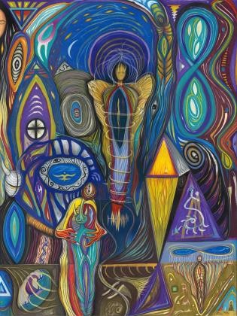

In all of this change, can we live blind?

What other species summons fire? Who else walks the earth with feet on ground, arms raised up in argument with the invisible truth?

Who else?

Can we live blind like cave dwellers who cling to walls, waiting for survival to crack their translucent skin?

Who else?

If we blame the gods or spirits or ghosts then we miss the connections. We become the nucleus of disconnection.

Blame pours like crude oil thickening, curdling, poisoning, filling the cavities so receptive to its leaden voice.

Our collective minds frame the savior

in golden tones of sin and shame. Fear strikes out and we call the invisible on our psychic phone to absolve us.

The blame is plain, it falls like rain. It enters like water fills a glass half empty.

Who else?

Zyanya

Chamber 16: Monument

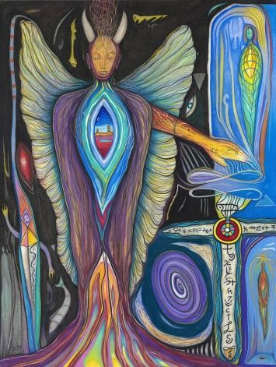

For if just once in its brief lifespan the mud-limbed creature staunch entrusts the entirety of its being to a single guiding star, without thought to consequence or charge, shorn of reservation and uncertainty, of indurate heart, of resolute mind, of immaculate soul… it is ever sung and honored within the senior ranks of bravery, notwithstanding the overt success of its mission.

The act of commitment bricks the monument; a willed reorientation of self to the nurture of the seed’s kernel, to the perfume of the flower of life from which all life springs. And should it be asked of me, a sprout of divine derivation, if the retrospective yields the lesson, I would proud salute in quiet reverie the God-spark’s passionate audacity that emboldens and animates the mundane.

Zyanya

Chamber 17: The Gates of Crumpled Paper

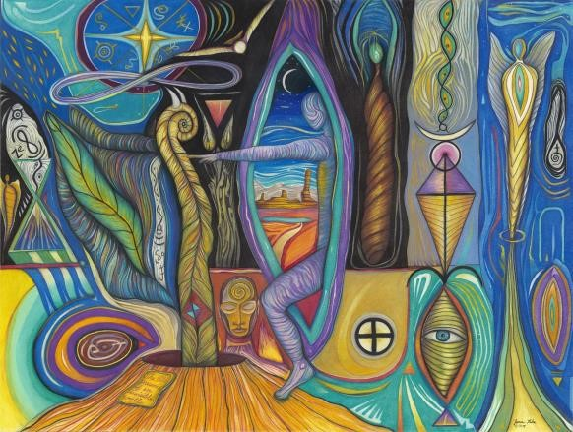

Inward goes the call. The writing proceeds, but the words
fall
beneath my gaze before they reach me.

A hand that is mine holds a pen that is yours over a paper that is ours. Its white geometry stares up at me like a gate, refusing me, using me to sour fate.

I know the madness inside you lurks, breeding with itself— each generation madder.
Until all of us, straining to see what is within, the last of kin a silent monster in my shadows.
Truly, it is not your fault that you are a petal of gold on the flower of disease. I have crumpled another page on the floor,
hoping to please you. Another gate refused to open so I closed its existence. Your pen is too fine for my words anyway. And my hand is tired of denial.

I can tolerate the savage smile.
The lock of hair cut in rage. The latch left open at night.
The blackouts that seize you in their cage. For that one small gift that you have given is not so small.

A muse of a lonely highway; of searchlights that prowl the night in a feast of anti-mimicry. You have brought me here to see the crumpled gates that my bare hands have laid before your madness.

In this aloof chaos we call earth we have both listened for the apology.
Stabbing at our brains’ indecision every ounce of us drenched in the sanctity of sweat.

The pitiless tint of crumpled paper surrounds me like birthmarks of the cream carpet face below. Lifeless and languid they imitate cruelty in their disavowal.

But like you, their denial is part of a calculation— the kind that is not kind.
“Tough love,” you said,
“is the only witness to true love.” You sacrificed your letting go so I could
walk above and below.
Gathering the words that had fallen prey to a matchstick’s fleeting light.

The small gift that you have given is not so small. It has no dimension. It has no presence at all, yet it gives permission like the sun to see.
The moon to dream.
The mountain to hope.
The ocean to feel.
The desert to desire.
The forest to commune. The earth to live. The human to love and to leave too soon.

I know you know us. You have pressed yourself to me in the falsetto of love’s voice. Not enough I thought, but it was enough to create us.

When you go on, past me, remember, any thought you might have of me, is not me. It can only be us,
because there was never a time when I walked or ran or crawled or laid on this land alone of you.
Never. Nie.
Never.

My deprived angel, if you go mad when my flesh is crumpled on the floor like a birthmark on Death’s face; I will crush the gates for you with my bare hands.
I will talk with the king.
I will tell him you are forgiven.
I will show him your small gift that is not so small.

“There is only mercy in a world of madness.” I remember your words’ stealthy aim. It was my heart, the one thing that cannot be reduced by a cage.

Like an evening shadow
I will wait the moment of your return. The king and I will walk the land together, listening for your arrival.
When you come,
I will run from my rations. I will lie atop you heart to heart; silent measures, transparent wings.
The holy art!

And the time of crumpled papers, of launching words like fireballs over moats, over stone walls into the deaf kingdoms that hold sanity dear… souls will finally sit with us around fires and cheer.

We are not crazy when we hold our breath as one lung. When we close our eyes to the punishment of purity. When stars speak to a leaf and we intercept the repartee, and smile as one.

Zyanya

Chamber 18: So, So Slowly

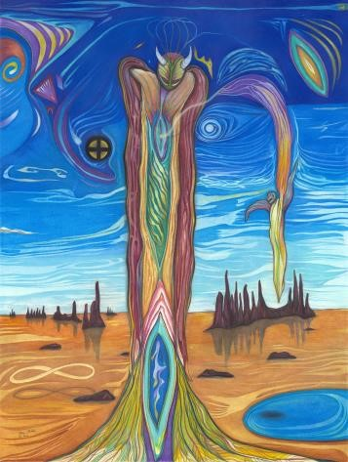

You cannot mute fire with Holy Water.
You cannot lure the wind to obey.
Yout cannot find the weakest in the stronger.
You cannot answer the questions that stay.

Cannot is the limit of can, that you cannot unbelieve.
If you live a full life’s span, gravity falls without reprieve.

Life is a humble, sprawling beast, a tinder night seeking embers. A castoff world unmoored released; licking losses it falsely remembers.

Behaviors beneath the skin bloom, their mount of the inner vessel complete. Vanity spreads the bristles of its broom, sweeping virtues to the street.

If we give, truly give of ourselves, the water within becomes holy. We learn what the universe tells, even though it seems to speak so, so slowly.
Zyanya

Chamber 19: Seat of Freewill

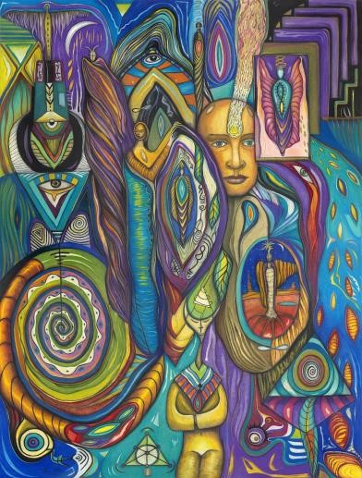

The heart steers the mind to unity and connection. The mind steers the heart to the red veils of separation.

Whose hands grasp the wheel?
It is called the seat of freewill for a reason.

Zyanya

Chamber 20: Real Gold

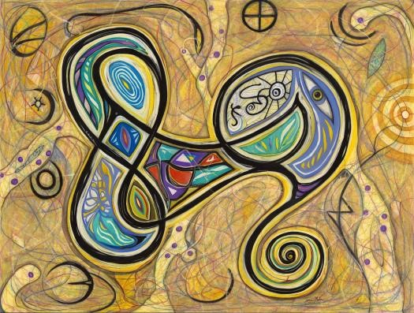

Following fires that bore into the land like storms driven by lightning, I see horizons cast deep, flung by powerful, emboldened arms. There, in that crease that folds mystery, I can see a future where ten billion differing beliefs disintegrate into one. Where the inside-out clarifies why slavery can finally die.

We have been wrapped in slavery since time was born on earth. We accept the husk, as if it was us.
The fools gold of spirituality. The dazzle of light.
The glamor of angelic hosts.
The vanity of hierarchies undisclosed. Its recipients; love-obsessed people with u-shaped mouths.

The sovereign is integral.
It is not cut-off from the motherload.
The pocket of gold spreads everywhere.
There is no mine to find.
We are it.
There is no have/have not.
There is only illusion.
The program.
The lie.

The truth?
Well, that is worth finding.
But it is underneath and beyond and invisible. It is cloaked and silent. It dreams us awake, and nightmares us asleep. It runs when we walk and walks when we crawl. It seems to tease like a harmless want. The truth is, it’s clear like perfect glass. An oasis or mirage? Somewhere in that midpoint, our enemies swarm intoning threats of sin.

We stand at the perfect glass, watching the tarnished gift of mortality. We delete love in every judgment and blame. Yet love remains the only game.

Zyanya

Chamber 21: Completion

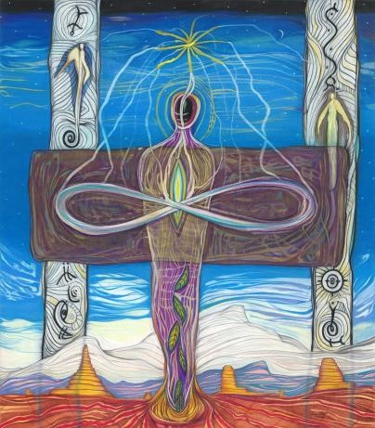

Completion.
Such an odd word, as if anything alive is complete. Everything is in motion, shapeshifting its way to new expressions. All to assemble at the mysterious attractor. We are untethering and reattaching simultaneously. Our experience is to change, modify, reconstitute, always to move on to the expression of our next.

Unless you draw the circle of time around a life, marking changes, completion does not exist. We are the cast that changes the stage, the script, the story’s arc, down to the final, immutable page.

Until we are complete, there is no completion.

Zyanya

Chamber 22: Purpose Penned

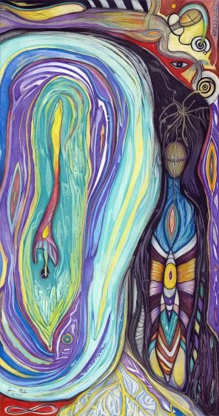

If I am free then walls do not exist. There are no iron bars that cross windows. No tape to seal lips. There are no wars that settle scores or torch the night in high-pitched wails.

If I am free then not a single child is hungry for love. There are no whispers of hate or glorification of handwritten fates.

If I am free then there is no path. Beliefs hurl their decrees, dissolved in the aftermath of an untold foretelling.

If I am free then so are you, even if we are transferred to the bottom shelf of the universe. We remain the selfless self, un-imprisoned in the unreal. We are stewards and shepherds of this recognition.
Purpose penned.

Zyanya

Chamber 23: What If

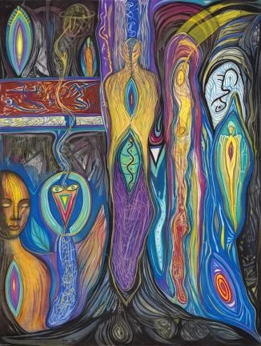

What if you could see the universe as your home?
What if you could talk with God...
I mean really talk with the universal spirit? What if the highest frequency in the universe circled you moment to moment. What if every morning you woke 11 million miles away?
What if you lived forever? Yes, yes, yes, yes, and yes.

What if your learnings were lost and you started anew?
Would you re-find them?
The very same ones? Why would you? The brilliant presence has suffered in the intellect.
Isn’t it time to do the penultimate crime and open eyes that lighten?

Zyanya

Chamber 24: Broken

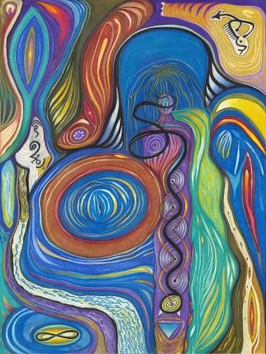

The frightened populace edges closer; a herd of ominous calamity, yawning at the wing-full sky.
Switching tails rally against the flies.
Predators creep in the borderlands. Some with bodies, some with only a watermark. A tightening spiral brings tension.
Tension brings wear.
Wear brings breakage. Breakage brings repair.

Healing is innate, if allowed. If a space is made, if a time is given, if an open mind receives; healing can step in. The graveled crowds gnaw on the bleached bones of sanctimony, hoping to find a nutrient path to accrete wisdom.

Wisdom is not found in the herd.
Wisdom is not found in the book. Wisdom is not found in the path.
Wisdom is not found in the other.

The mind’s scrapbook interior hoarded dreams and desires like the pantry of a billionaire.
But where is wisdom on the shelf?

Wisdom is healing.
It is what recognizes and repairs
the broken.

Aayda

Chamber 1: Fallacy of Form

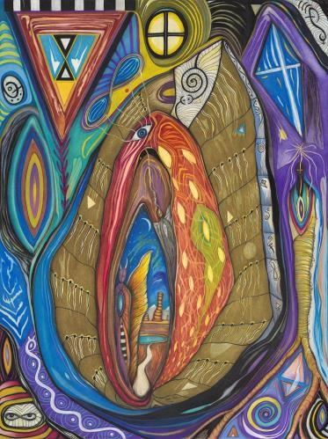

Not all lies are the same. Not all illusions have their roots in soil. Fallacies do not rise up to reveal the truth, no matter what you have been told.

The fallacy of form is welded to the fallacy of space. Together, they are the serpent that dangles from the tree. The apple falls from its mouth, regurgitated so you can be alike.

The fallacy of form is that we are different. and in that difference we mesh, interleave, conjoin to create the formless in form. We, the creation, create the creation. The cycle repeats itself, leading to the great portal
when we all wake to our collective godhood and in one smile extinguish the fallacy of form.

Aayda

Chamber 2: Unity

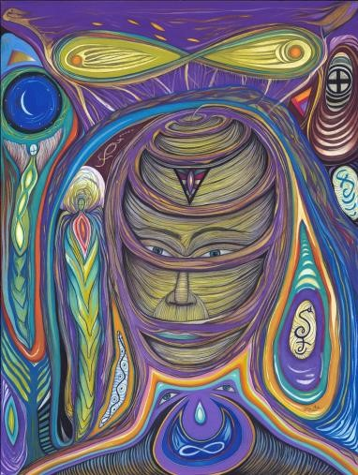

Too young to be lost you need a world that is true. No cape with deliver you, no payment will cover the cost so long overdue.

You are more than a name; given by your past to a soul merely loaned. In all the mirrors
I have crossed
I have seen only one face unowned.
Unattributed. The mirrorless absorption of all things sacred. That secret network that churns duality to make unity aware of itself.

Chamber 3: Perspective Matters

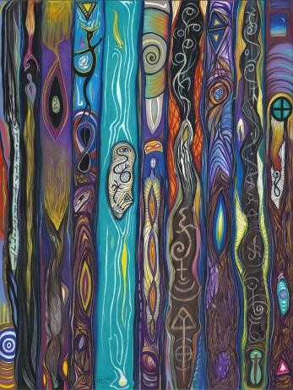

A program exists.
Yes?
No?
Your disagreement proves you are inside it.
Blissfully oblivious.
Painfully unaware of its sharp edges. The program is deeply seated, passed from generation to generation, embedded like oxygen in water. DNA carries it, hoisting it into our vaulted minds where pictures pour cement for the imprinting.

Is it enough to know the program?
You can study it.
Analyze it. Rip every covering off of it until you are staring into the face of a sinister plan to enslave, manipulate, repress, diminish that part of you that is both sovereign and integral.

The house of mirrors smiles.
There is always another level. An expansion waiting.
Isn’t the program a part of the expansion? Where we feign ignorance in order to gain our difference?

If you hate the program, you are flicking embers into the tinder night, summoning a fire with fatal persistence. There is an implicate order that embraces us.
Better to allow than hate.
Better to resist than sate.
Better to follow your heart than fate.
Better to understand now than too late.

The program is a tiny oder in the glorious feast of immortal life.
Perspective matters.

Chamber 4: Trained Ways

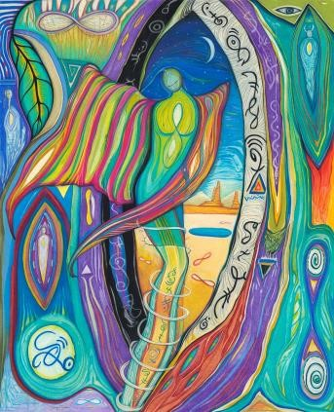

We were trained to retreat. To circle the core like a moon reflecting light without gravity. We were trained to live blind of the profound spaces; frequencies we shuttered like masks over faces. We were trained to ignore the endless plea of our heart’s instinct to steer inward to feel the link of our soul. We were trained to believe words and numbers, as if they pointed the way to the ultimate truth, but truth never encumbers.
Truth displays itself in those rare, random moments that cannot be trained or coaxed into our perception. The shadows, however, of that ultimate truth, do protrude, expressed in a million different trained ways.

Aayda

Chamber 5: The Voice

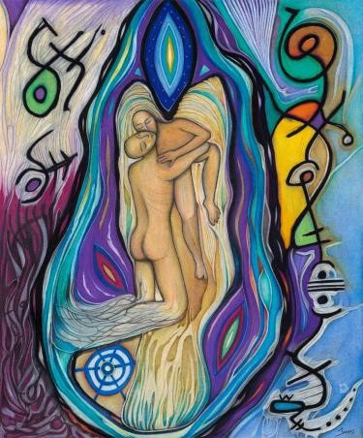

I wept the name out loud; the universe stilled to listen. Orbiting planets patrolled the crowd that gathered with glistening eyes.
I sang it true; I sang it proud, with calm tones I christened it. It bore the sacred fire impervious to time, unbounded by a single hour it knew only how to climb.

That sound traversed the spacious skies, a sung bolt surging through portals obscure. The cosmos, free of any malady or cure, stood up and bowed, the summation of all material forms. Out of this deep, impenetrable void, a voice flung itself across the absonite empire In search of us all.

Chamber 6: Unknowable
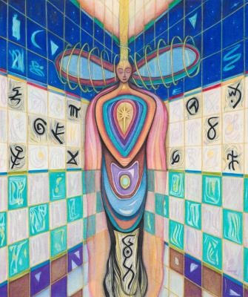

Claws fully extended defined in fire, I close my eyes and see ocean floors, the sky’s abandonment. Calm, liquid peace.
The heart’s intellect awakens here. Above, the out-bound world drifts in a sea of verdicts; hoping to find and hold the unknowable. Forgetfulness is the sanction of reorientation.

They have forgotten the reason it is called unknowable.

NOTE: The rest of the Aadhya poetry will be added over time. Check back on the
WingMakers.com site for updates, or register on the site to get updates as they happen.

